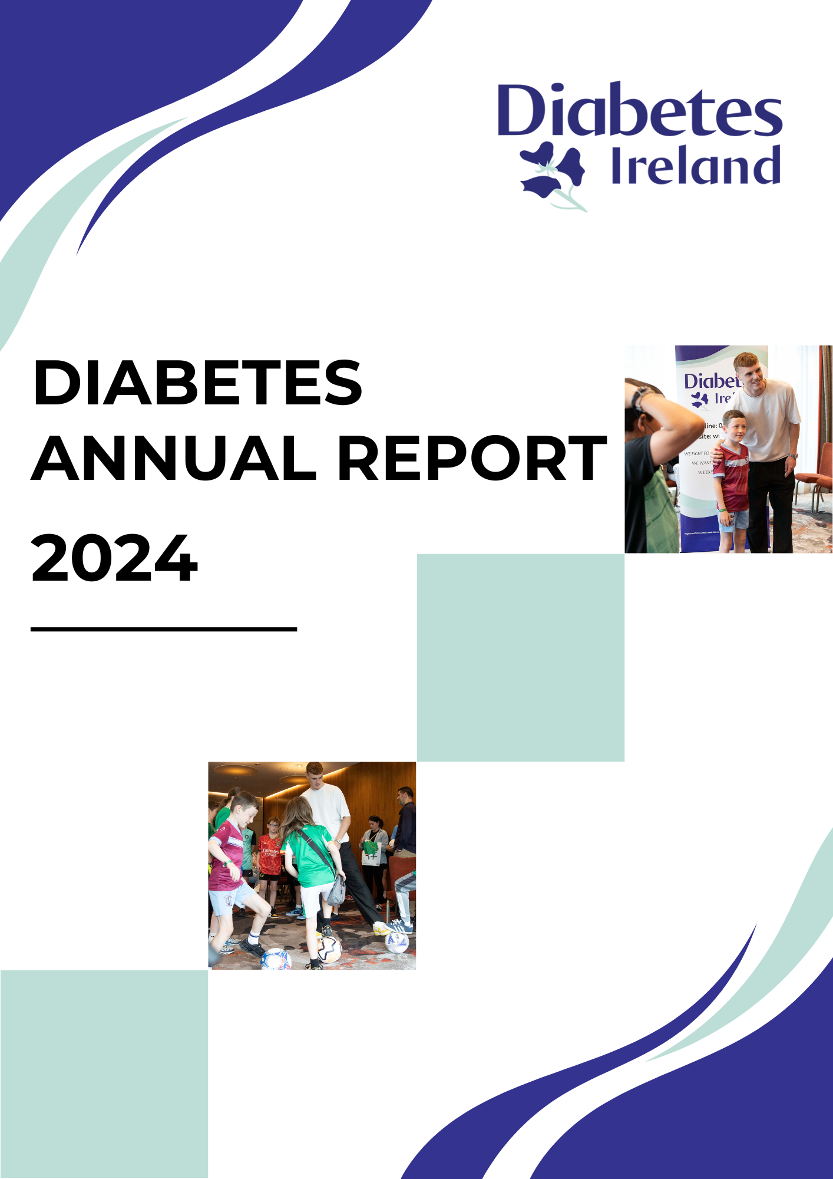
Foreword

2024 was a pivotal year for Diabetes Ireland as we strengthened our commitment to advocacy, education, and support for the diabetes community across Ireland. Central to our work remains the mission to empower people with diabetes and their families, ensuring they have the resources, knowledge, and support needed to live well with diabetes. We continued to engage directly with government and health stakeholders, pushing for meaningful improvements in diabetes services and securing commitments to improve access and care nationwide.
Advocacy was at the forefront of our work this year, with the long-awaited announcement by Minister for Health Stephen Donnelly TD to establish a Diabetes Policy and Services Review. This initiative, which will identify service gaps and recommend actions to improve diabetes care nationwide, was widely welcomed by the diabetes community. Our “Ask Your Local Candidates” campaign ahead of the general election mobilised people living with diabetes to seek political commitments to the development and implementation of the recommendations of this review which we hope to see launched in 2025.
Supporting and educating people living with diabetes and their families remained a core focus. We supported thousands of people through our helpline, education programmes, website and innovative digital tools like the DigiBete App, now used by over 1,170 families of children and teens with Type 1 diabetes. Our community events and workshops continued to provide vital peer support and practical information that help people with diabetes and their families navigate the challenges of daily diabetes management.
Key events and initiatives strengthened community engagement, including the Diabetes Health Awareness Exhibition, which welcomed over 2,000 attendees, and various family and teen events that brought together families and dozens of teenagers for peer support and fun activities. The “Living Well with Diabetes” medal ceremonies saw a further 75 individuals managing diabetes honoured in 2024, celebrating resilience and long-term self-management.
We continued to make significant progress in developing our Mental Health & Wellbeing Support Programme. This initiative addresses the lack of psychological services for people with diabetes who attended tailored pilot programmes for adults with Type 2 diabetes, parents of children with Type 1 diabetes and for adults newly diagnosed with Type 1 diabetes. Early feedback has been overwhelmingly positive, highlighting the urgent need for ongoing mental health support within diabetes care. We hope to finalise the various programmes in 2025 and make them available to the diabetes community.
The charity also welcomed Republic of Ireland and Everton FC footballer Jake O’Brien as an ambassador, who wants to inspire young people by sharing his journey of managing Type 1 diabetes while pursuing a professional sports career. Jake actively supports awareness campaigns, notably the TEST campaign that educates the public on early symptoms of Type 1 diabetes.
Supporting healthcare professionals was also a priority in 2024. Diabetes Ireland hosted its annual DICE conference for 300 professionals and supported the inaugural launch of the Diabetes Technology Network Ireland (DTN IRL), a major step forward in advancing diabetes technology education and access for more people with diabetes. With 160 attendees, the inaugural conference brought international expertise and practical training on using CGMs, insulin pumps, and hybrid closed-loop systems. Alongside this, Diabetes Ireland launched a new ezine for healthcare professionals ran webinars for practice nurses, and actively supported research initiatives. Collectively, these efforts strengthened professional knowledge and collaboration while pushing for improved access to diabetes care and technology across Ireland. Additionally, we delivered numerous information sessions across diverse community groups, including Men’s and Women’s Sheds, workplaces, nursing homes and school staff highlighting the importance of diabetes prevention, early recognition, and daily management.
As Ireland’s only national charity solely focused on supporting people with diabetes and their families, Diabetes Ireland carries a vital responsibility in delivering quality services and advocating for better care. The charity remains committed to its mission of empowering, educating, and supporting those living with diabetes while striving to ensure equitable access to the best possible healthcare. Looking ahead, Diabetes Ireland is focused not only on sustaining its current services but also on expanding them to meet the growing needs of the diabetes community across the country.

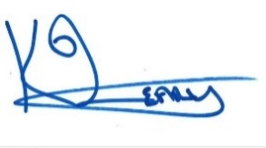
Diabetes Ireland extends its heartfelt thanks to everyone who contributes to its work — from volunteers and healthcare professionals to those who fundraise, corporate partners, HSE and our members. The combined support makes it possible to improve the lives of thousands of people living with diabetes. Continued collaboration and community engagement are essential, and we encourage both existing and new members to stay involved so that, together, progress can be made toward a healthier future for all people with diabetes in Ireland.

Professor Hilary Hoey Kieran O’Leary
Chairperson CEO

Contents
About Diabetes Ireland |  |  |  |  | 4
Acknowledgements |  |  |  |  | 5
Support and Education Service Highlights |  |  |  |  | 7
Education & Support |  |  |  |  | 15
Diabetes Awareness in the Community |  |  |  |  | 18
Direct Patient Care Services |  |  |  |  | 21
Diabetes Advocacy |  |  |  |  | 22
Diabetes Research |  |  |  |  | 26
Structure, Governance and Management |  |  |  |  | 27
Finance & Fundraising |  |  |  |  | 28
Statement of Accounts 2023 |  |  |  |  | 29
Diabetes Ireland

Founded in 1967, Diabetes Ireland is a national charity dedicated to helping people with diabetes. It achieves this by providing support, education and motivation to all people affected by diabetes. The charity also raises public awareness of diabetes and its symptoms, fosters programmes for the early detection and prevention of diabetes complications and supports advances in diabetes care and research that will improve standards of care and quality of life for people with diabetes.

Our Vision

“To ensure everyone with diabetes has the support and confidence to live a long and healthy life.”

Our Mission

“To provide a quality service in improving the lives of people affected by diabetes and working with others to prevent and cure diabetes.”

Our Aims

- To provide support, education, and motivation to people with diabetes, their families, and friends.
- To raise awareness of diabetes in the community and foster programmes for early detection and prevention of diabetes complications and its burden.
- To support and encourage advances in diabetes care and research that improves Quality of Life and Standards of Care.

Our Board

Every member of our board freely donates their time, their skills, and their experience to help support the diabetes community through our work.

Directors

Professor Hilary Hoey Chairperson
Ms Colette McLoughlin Treasurer
Mr Daniel McDaid Secretary
Mr Cormac Gollogly
Mr Phil Miesle
Mr Patrick Power
Ms Marie Ronan
Ms Barbara Scott
Kieran O’Leary CEO

Acknowledgements

Diabetes Ireland would like to acknowledge and sincerely thank;

- its staff, volunteers, and healthcare professionals for their continuing support.
- corporate partners for their support and assistance with our various initiatives and services.
- members, supporters, and donors for their help in raising vital funds to enable us to continue our work.
- the Health Service Executive for their financial support which enables us to provide our services.

Diabetes Ireland is fully compliant with the Charities Regulatory Authority. Diabetes Ireland is committed to achieving the standards contained within the Statement for Guiding Principles of Fundraising. Diabetes Ireland is proud to have achieved the Triple Lock member award with the Charities Institute. Triple Lock is awarded to charities that uphold the best practice standards in ethical fundraising, transparent reporting, and strong governance.

Supporting Partners
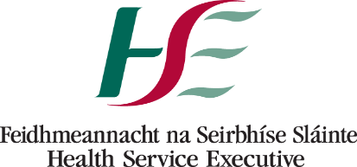

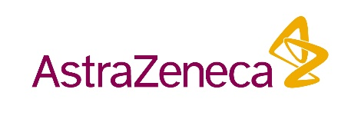


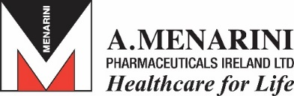







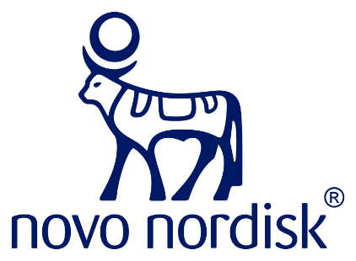




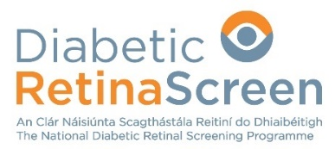
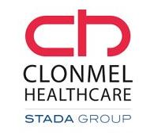
Other Partners





Some of our 2024 highlights: ✨

Ireland’s First National Diabetes Strategy

A long-awaited day for the diabetes community in Ireland
In July 2024, Minister for Health Stephen Donnelly TD launched the Diabetes Policy and Services Review Group to develop Ireland’s first-ever National Diabetes Strategy.
“Diabetes is a major health challenge for our population, and managing Diabetes is a major challenge for our health services” – said Minister Donnelly. “I have mandated the establishment of the Diabetes Policy and Services Review, so we can improve patient outcomes, minimise the health complications associated with diabetes, and ensure that our health services are best organised to provide the patient care and support needed by people living with diabetes
The group included people with diabetes, clinicians, advocates, and health service managers, and was chaired by Professor Derek O’Keeffe, HSE National Clinical Lead for Diabetes. He described the initiative as “a collaborative effort to build a better future for diabetes care in Ireland.”

Kieran O’Leary, CEO of Diabetes Ireland, called the review “the most important initiative we’ve been part of in decades,” urging that the needs of people with diabetes stay at the centre of all decisions. Dr Kate Gajewska of Diabetes Ireland added, “This reflects years of advocacy and shows what can be achieved when people with diabetes, carers, and professionals work together.”
With over 308,000 people living with diabetes, the strategy aims to improve outcomes, reduce complications, address service gaps, and create a practical, fundable plan for diabetes care service going forward. A final report with recommendations will go the Minister for Health in early 2025.
We would like to thank all our supporters – all those who sent their parliamentary questions, who raised their voices, contacted their TDs and senators, and all those who fought and still fight together for better services, access to care, technology and medicines. We hope that the outcome of this Diabetes Policy and Services Review provides equal access to quality diabetes care to all – no matter the type, age, geographic location or socio-economic status in Ireland.

Advancing Mental Health & Wellbeing Support for People with Diabetes

In 2024, Diabetes Ireland made significant progress in developing a national Diabetes Mental Health & Wellbeing Support Programme to address the lack of psychological support for people with diabetes and their families. Despite HSE guidelines recommending the inclusion of psychologists in diabetes care teams, adult services still have no dedicated psychological support, and national planning in this area remains limited.
Mental health challenges—such as depression, anxiety, eating disorders, and diabetes distress—are more common in people with diabetes. These can seriously affect self-management and health outcomes. In response, Diabetes Ireland has focused on building tailored support programmes across three key groups: people with Type 2 diabetes, parents of children with Type 1 diabetes, and adults newly diagnosed with Type 1 diabetes.
Type 2 Diabetes Programme

In 2024, pilot sessions were delivered to 104 participants across two phases. Feedback from focus groups and attendees led to the creation of a structured 4-session programme (2 hours per session), promoting peer learning and ongoing support. A formal evaluation in partnership with UCD School of Psychology began in late 2024 and will continue in 2025, including delivery and review of four additional programmes.

Family Wellbeing Programme (Type 1 Diabetes – Parents)

Pilot sessions were developed for parents of children under and over 12 years old, with 36 participants attending in 2024. The programme was adapted to include two 2-hour sessions, providing a space for shared experiences and peer support—especially valued by parents of newly diagnosed children. A workbook is in development to support future rollout.

Adult Type 1 Diabetes Programme

Acknowledging the unique mental health challenges in adults with Type 1 diabetes, work began in 2024 on developing a dedicated support programme for adults newly diagnosed with the condition. Pilot delivery is planned for 2025.
In 2025, Diabetes Ireland will continue formal evaluation, content development, and programme expansion to ensure more people living with diabetes—and their families—have access to meaningful, structured mental health and wellbeing support. This initiative us supported by HSE grant funding.

Republic of Ireland footballer Jake O’Brien becomes an ambassador of Diabetes Ireland
Cork native, Jake O’Brien of Everton FC who made his Republic of Ireland senior debut this year announced his new role of becoming an ambassador of Diabetes Ireland.
When home in Cork to see his family in July, Jake met with some young children and teens living with Type 1 diabetes and their families who actively volunteer with the charity where he spent time answering questions from what it was like to play against Christiano Ronaldo and Kylian Mbappe to how he manages his Type 1 diabetes on a daily basis.


As a professional footballer with Type 1 diabetes, Jake has joined current international star as Nacho Fernandez – Real Madrid captain, multiple champion league medal winner who is currently at Euros 2024 with Spain who was diagnosed at 12 years of age, and past Irish internationals Alan Kernaghan who played 26 times for the Republic of Ireland and played for a host of clubs including Manchester City in the English Premier League and Gary Mabbutt, England captain and Tottenham Hotspur who both live with Type 1 diabetes.

Diagnosed at 16 years of age when he noticed he was losing, rather than gaining weight, while working out in the gym, he knew something was not quite right. After speaking to his parents who felt he was looking very pale, he went to the GP who checked his blood glucose levels which were very high and encouraged him to go to Cork University Hospital where he was diagnosed with Type 1 diabetes.
Jake said “I didn’t know very much about Type 1 diabetes but I looked at it positively and decided right away to adapt it into my lifestyle and training and manage it effectively”.
On becoming an ambassador of Diabetes Ireland he continued “I want to promote a positive message to everyone living with diabetes, especially young people and encourage them to strive to achieve their dreams and prove that diabetes is not a barrier to achieving your life goals, whatever they may be. I have kept an eye on the work of Diabetes Ireland for quite a while and I have seen how they work to provide support to people of all ages living with diabetes and I reached out to them to see how I could help to raise awareness of diabetes and I am delighted they asked me to be an ambassador”.
Jake is especially keen to raise awareness of Type 1 diabetes and highlights the TEST Campaign as a hugely significant initiative in raising awareness of the symptoms of Type 1 diabetes among the wider population equipping individuals to recognise the signs early, seek help and avoid the development of Diabetic Ketoacidosis (DKA). TEST which is easy to remember as an acronym represents the symptoms of Type 1 diabetes. “We all need to know the symptoms of Type 1 diabetes so we can recognise them early and take action. The symptoms are the key indicators that you or your child might have Type 1 diabetes” said Jake.

Kieran O’Leary, CEO of Diabetes Ireland said “we are delighted Jake approached us and offered to help us in our efforts to support the diabetes community. As a role model for children and teens living with Type 1 diabetes, I am sure his story of positivity and determination in working hard to achieve his dream of playing professional football, having the confidence to go abroad at a relatively young age, and not long after his diagnosis, to achieve his own personal goals will be a very powerful and welcoming message for families of young people with Type 1 diabetes and for the thousands of young adults living with Type 1 diabetes in Ireland.

Diabetes Health Awareness Exhibition 🎉
As part of World Diabetes Week celebrations, a Diabetes Health Awareness Exhibition & Conference for people with diabetes and their families was held in Dublin. Over 2,000 people freely availed of Blood Pressure checks, Weight and Waist Circumference assessments and CPR Introduction sessions along with a number of education workshops for people living with Type 1 and Type 2 diabetes. There were a number companies exhibiting on the day, showcasing the latest medical technology along with a number of healthy living stands and other diabetes-related services in attendance to answer queries from attendees.
The workshops for people with Type 1 diabetes focussed on the availability of, and benefits of, diabetes technology in your daily management. Together with Diabetes Technology Network (Ireland), there were interesting sessions provided by diabetes technology specialists, Dr Hannah Forde, Consultant Endocrinologist, Beaumont Hospital, who provided an overview of diabetes technologies available in Ireland and how to use them best and Ms Mary Finn, Clinical & Research Dietitian, Tallaght Hospital, who discussed using diabetes technology to understand the impact of exercise in managing your condition.
For adults with Type 2 diabetes, Dr Michael Lockhart, Consultant Endocrinologist, University Hospital Galway spoke about the importance of good diabetes management, understanding what the various blood tests results are telling you and how to improve them while Ms Louise Enright, Psychologist and Ms Louise McHugh, Senior Podiatrist spoke about looking after your mental health and caring for your feet respectively.

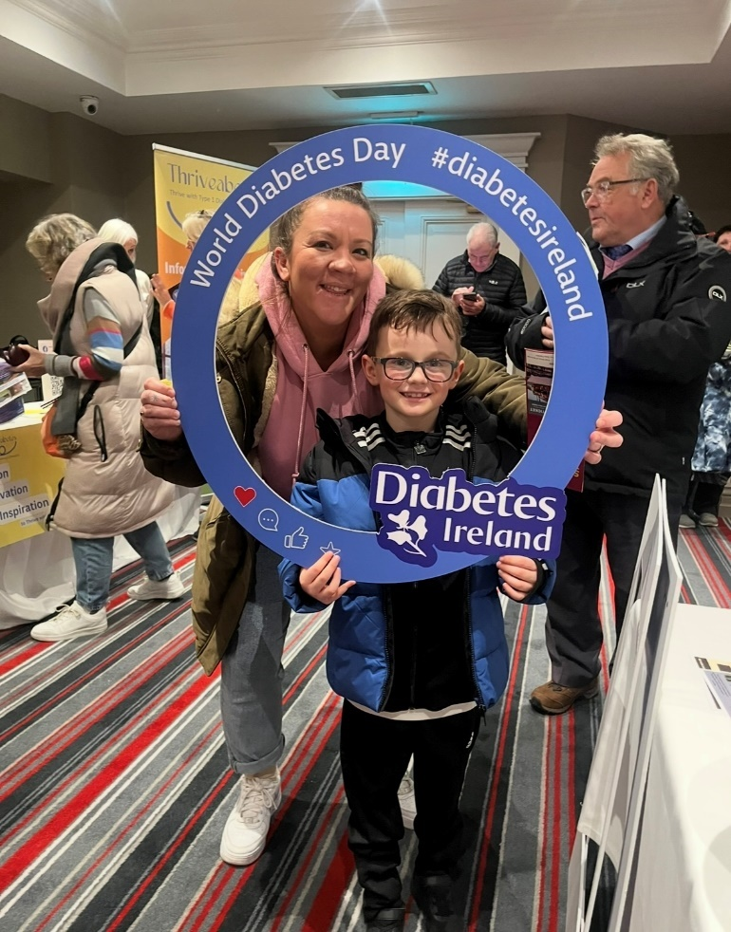
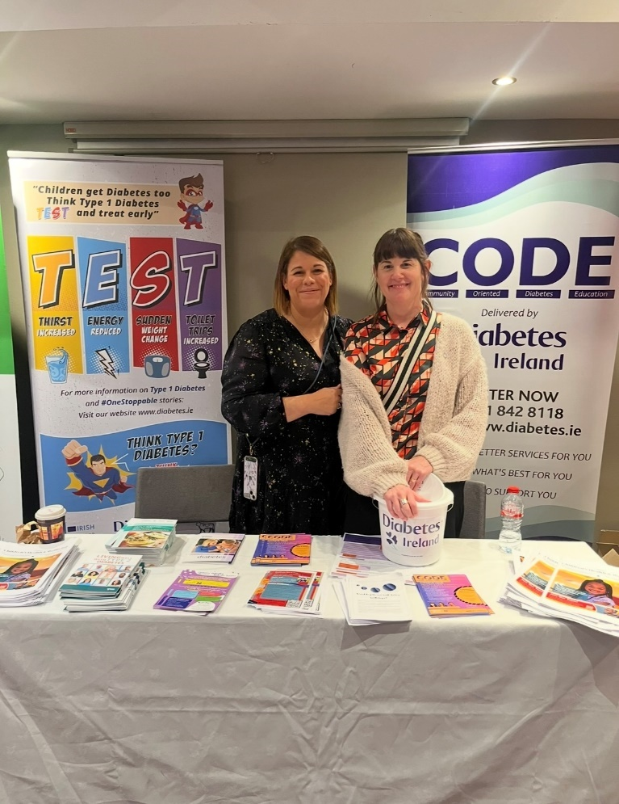

Some more of our 2024 highlights: ✨

Focus on our Cork Care Centre

In 2024, our Cork Care Centre was a hive of activity, with staff working hard each day to support the local diabetes community. The centre has become a valued local resource service for people seeking support and information on the many facets of diabetes and also in providing a range of practical care services in the areas of diabetic retina screening, podiatry and one to one counselling. This year, approximately 9,750 people living with diabetes physically attended the Centre to avail of one or more of our care services. A further 600 people contacted the centre to speak directly with our staff on various aspects of diabetes management.

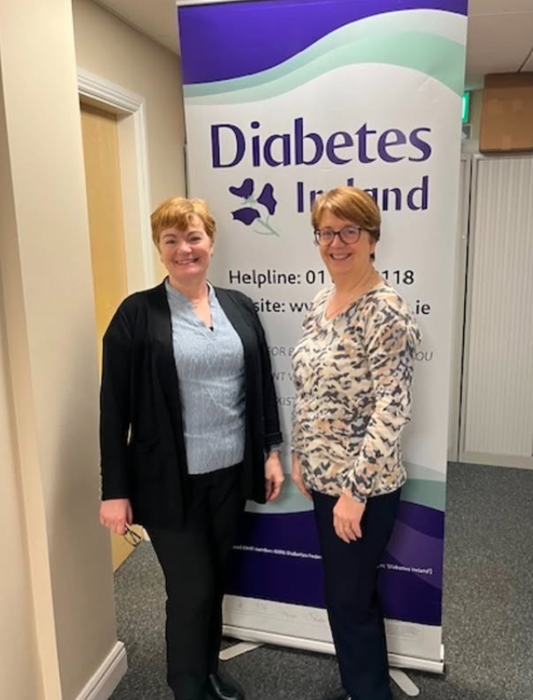
Diabetes Ireland also focussed on providing opportunities for young local people with diabetes and their families to come together and meet other families. Local staff members, Charlotte Pearson and Marion Sheehan along with a number of volunteer parents, organised a number of local activities including a fun day in Mardyke Arena, a family walk and a Christmas Party with over 90 children and their families taking part in one or more events.

They also organised a summer outing to Dunmore East Activity Centre for local adolescents with Type 1 diabetes to have some fun and meet their peers and a weekend camp in Barretstown, run in conjunction with the paediatric diabetes team in Cork University Hospital.

An event to meet Diabetes Ireland Ambassador, and Cork protégé, Jake O’Brien who plays for Everton and is Republic of Ireland senior international was also held for local families where Jake shared his experience of living with Type 1 diabetes and encouraged the children to learn to manage their diabetes effectively and to not allow it to be a barrier to achieving their life dreams.

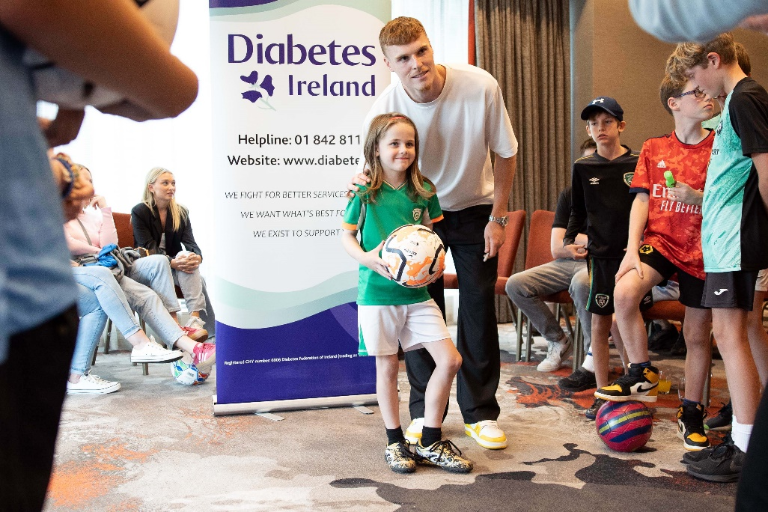

An education meeting for parents of adolescents with Type 1 diabetes was also held in UCC where Ms Shirley Beattie, Senior Dietitian, CUH spoke on sport and nutrition for teens with diabetes.

In conjunction with the adult diabetes team in Tralee General Hospital, an information meeting was held in Tralee, Co. Kerry with 160 attendees. Speakers included Ms Shirley Beattie, Senior Dietitian, Cork University Hospital on diet and exercise and Ms Catherine Brady who spoke about her own life experience of living with Type 1 Diabetes and being a multi world championship winning kickboxer. At the same event, a ceremony to recognise the achievements of local people who have lived well with diabetes for 50 years was also held with 11 people being recognised and awarded with commemoration medals.

Behind the scenes, local staff also worked to make things easier for children with Type 1 diabetes while at school. With local paediatric diabetes experts from Cork University Hospital, we delivered a webinar to 170 schools across Cork and Kerry to help them prepare and manage any diabetes related situation that may arise during the school day and also delivered a number of diabetes awareness events in local workplaces.

Diabetes Ireland continued its work with the Cork University Hospital (CUH) paediatric diabetes team to bring Digibete, the multi-award-winning digital diabetes self-management resource to Cork. This is a licence-based resource programme, being funded by Diabetes Ireland, and provided free to HSE paediatric diabetes teams to help improve care services to children and adolescents with Type 1 diabetes and their families. At 31 December 2024, 293 families of children and teens living with diabetes in Cork were using the programme.

Charlotte Pearson said “our goal is to support local people with diabetes as best we can within our resources. Working with the HSE Diabetic RetinaScreen programme, the diabetes teams in the various local hospitals and other stakeholders, we are planning to do more of the same in 2025. If you, or a family member are living with diabetes and you would like some help or advice, please don’t hesitate to reach out to us”

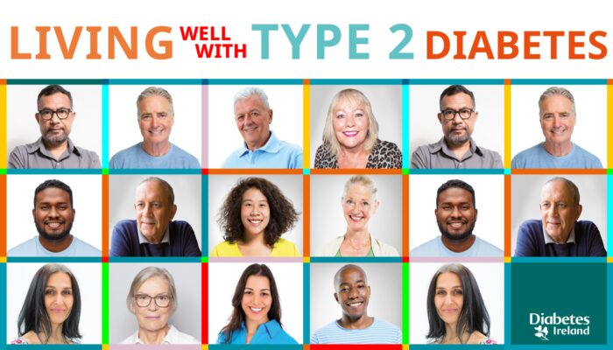
Unveiling the Revamped Guide: 'Living Well with Type 2 Diabetes' Booklet

Diabetes Ireland launched its newly updated “Living well with Type 2 Diabetes” booklet in April 2024. This resource serves as a valuable guide for individuals and families affected by Type 2 diabetes, offering easily understandable information from diagnosis to daily management to promote a healthy lifestyle.

Navigating a diagnosis of Type 2 Diabetes can be overwhelming due to the abundance of information available, which can often be confusing. To address this, the booklet has been divided into two sections. The first section provides essential information for individuals who are newly diagnosed, assisting them as they embark on their journey with Type 2 diabetes. The second section offers more comprehensive guidance on managing the condition on a day-to-day basis.

A notable addition to this updated version is the inclusion of a Personal Plan and record of results. This feature transforms the booklet into a comprehensive tool for information, goal setting, and tracking personal data such as blood results, blood pressure, and BMI. Additionally, it serves as a convenient place to record appointments, including retina screening schedules.

The redesign and reprint of this booklet were made possible through an educational grant from A. Menarini Pharmaceuticals Ireland Ltd.


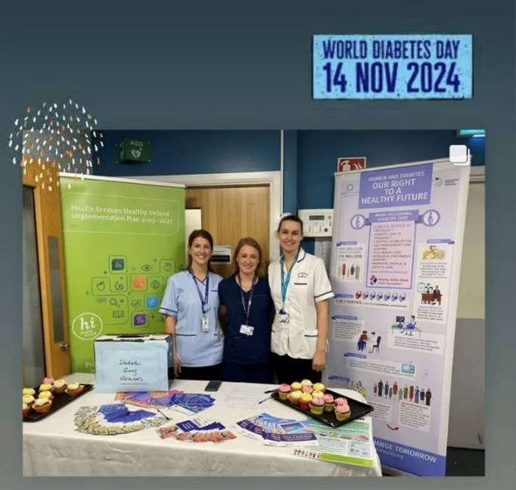
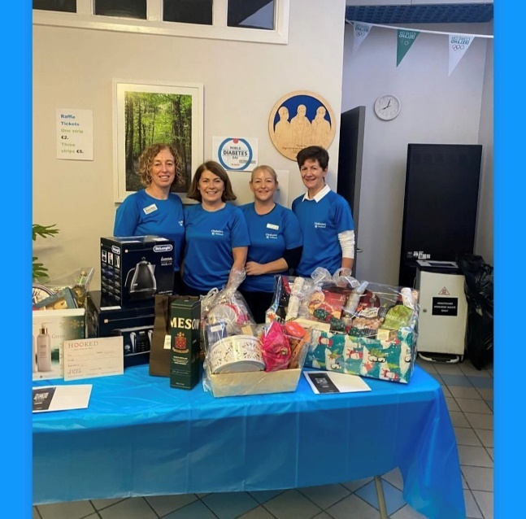
🌍 United in Blue for World Diabetes Day 2024

🏅 Inspiring Achievement: Irish Life Marathon 2023 Raises €38,000
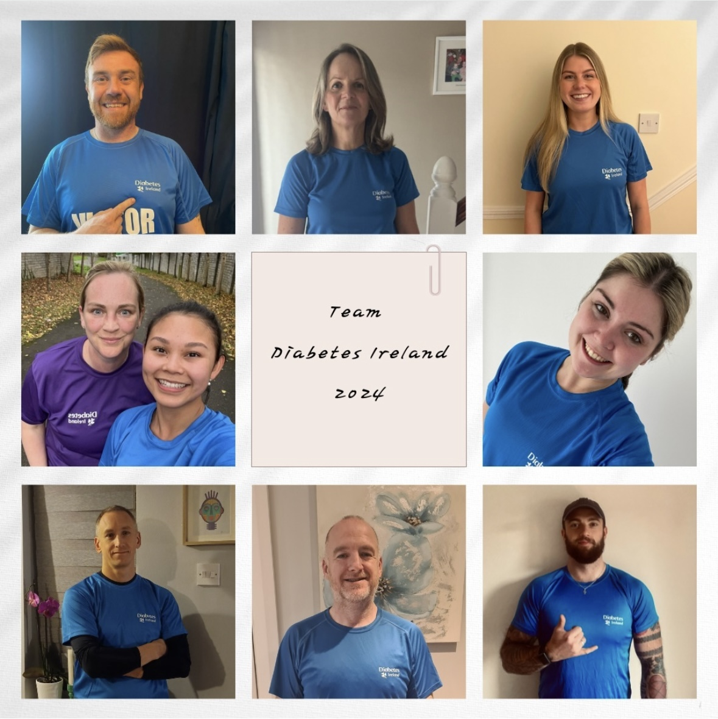
32 runners participated in the Irish Life Marathon 2023, showcasing individuals living with type 1 or type 2 diabetes, or those closely connected to someone affected by diabetes, and demonstrating the personal commitment and passion each member brought to the event
Education & Support
People who avail of our services and attend our events find them informative and helpful. An estimated 308,948 people are living with diabetes in Ireland of which 272,904 live with Type 2 diabetes and 30,895 live with Type 1 diabetes. Access to reliable, trusted, clear and concise information is paramount to helping manage their condition on a daily basis. Our services are there for people living with diabetes and their families who require support in their time of need.
In 2024, Diabetes Ireland continued to provide its many services to the diabetes community ensuring that thousands of people continued to receive education, support, and motivation to maintain good management of their condition.
2024
- Regular Education Webinars: We continued to provide education webinars for people living with diabetes and their families. We held 2 very well attended webinars with very positive feedback from attendees. Our webinars aim to provide people with practical information around the various aspects of living daily with diabetes. The webinars covered the topics of exercise for people living with Type 1 diabetes and heart failure prevention. More than 500 people attended one or more of the webinars during the year.
- CODE Structured Education Programme: 14 CODE Structured Education programmes were delivered virtually to 150 participants living with Type 2 diabetes. Feedback was extremely positive with participants appreciative of being able to attend the programme from the comfort of their own homes.
- Diabetes Smart: 116,000 visits to Diabetes Smart”, our online interactive educational programme in 2023. The Diabetes Smart programme is based on the principles of CODE for use by GPs and people at risk and/or diagnosed with Type 2 diabetes. The programme is supported by Novo Nordisk.
- Diabetes Ireland Helpline: 5,322 people contacted our Diabetes Helpline in 2024. 25% of callers sought general information on diabetes management, 62% sought specific information and support on accessing services, 6% on personal advocacy issues such as insurance, school, work and HSE services and the remaining 7% sought information on upcoming events and other issues.
- Diabetes Ireland Magazine: Three issues of our magazine “Diabetes Ireland” were produced and disseminated to 3,700 families in 2024.
- Monthly Ezine: Thousands of people, including our members, received a monthly ezine bringing them the latest news, diabetes updates, events, programmes and highlights throughout the year.
- A new and updated “Living Well with Type 2 Diabetes booklet was launched in April 2024. This resource serves as a valuable guide for individuals and families affected by Type 2 diabetes, offering easily understandable information from diagnosis to daily management. With support from A.Menarini Pharmaceuticals Ltd., copies of the booklet are made available in GP services and HSE Chronic Disease Management Community Hubs nationwide.
- Diabetes Health Awareness Exhibition: As part of World Diabetes Week celebrations, a Diabetes Health Awareness Exhibition & Conference for people with diabetes and their families was held in Dublin. Over 2,000 people freely availed of Blood Pressure checks, Weight and Waist Circumference assessments and CPR Introduction sessions along with a range of education workshops for people living with Type 1 and Type 2 diabetes. There were a wide range of companies exhibiting on the day, showcasing the latest medical technology along with a number of healthy living stands and other diabetes-related services in attendance to answer queries from attendees.
- Living Well with Diabetes Medal Ceremonies: Each year, Diabetes Ireland recognises people who are living well with diabetes for more than 50 years. In 2024, ceremonies to honour this year’s recipients were held in Dublin, Galway, Kerry and Sligo. Seventy-five people were honoured with 69 receiving a “50 Year Living Well With Diabetes” medal and 7 receiving a “65 Year Living Well With Diabetes” medal. This group of recipients are among a special group of 317 people who have been honoured with 17 of those receiving a 65 year medal.
- Family Events: We held a number of events for younger children living with Type 1 diabetes and their families with summer events in Cork and Mayo plus christmas parties in Cork, Donegal, and Dublin. A Family Weekend was also held in Donegal. 116 families attended one or more of these events.
- Teen Camp: The sun came out and shone brightly for this year’s Teen Camp in Barretstown. The parents left, the fun began and didn’t stop. From Silly Olympics to horse riding, kayaking, archery, creative theatre, dancing and performing to most importantly making new friends, it was all go. A massive thank you to all of the paediatric diabetes medical team and volunteers from Diabetes Ireland, Cork University Hospital and Children’s Hospital Ireland who gave up their weekend to make this happen. They along with Barretstown staff and Cara’s were fantastic but it was our remarkable 36 teens who truly stole the spotlight. The weekend was not only filled with fun and adventure but also fostered countless new friendships, underscoring the immense value of the Camp experience.
- Teen Activity Day: Forty seven teenagers attended venues in Waterford and Roscommon for this year’s event. Supported by diabetes nurses, volunteers and Diabetes Ireland staff, a fantastic day was had by all with the teens doing a series of land and water-based activities such as Boda Borg, kayaking, wall climbing paddle boarding, Wibit Aquapark and good old pier jumping, everyone made lots of new friends making it a great day for all.
- Carers Diabetes Education Programme: We delivered 5 Carers Diabetes Education Programmes to 94 professional carers/staff working in Nursing Homes, Residential Homes, and Intellectual Disability Centres nationwide. The programme promotes the benefits of healthy food choices in modifying risk factors for people at risk of developing, or with, Type 2 diabetes.
- Schools Diabetes Awareness Programme: We delivered 18 education sessions to over 650 teachers and special needs assistants on managing Type 1 diabetes in during school hours. In conjunction with Cork University Hospital diabetes paediatric team, we held a further session for 170 schools across the counties of Cork and Kerry.
- Diabetes Mental Health & Emotional Wellbeing Support Programme: Work on the developing this programme continued in 2024. See page xxx for more information.
- Digibete Self-Management App & Video Platform: In February, Diabetes Ireland launched the multi-award-winning DigiBete Self-Management App and Video Platform in Ireland. With support from West Pharmaceutical Services, Diabetes Ireland purchased the licence to bring the app to Ireland. The App helps to improve care for children and young people with diabetes by helping them manage their condition more effectively and provides an easy cost-free communication stream for hospital paediatric diabetes teams to engage with families to provide clinical advice and information. The App is available to children and young people with diabetes and their families through their paediatric diabetes team in early 2024. See article below.

Hundreds of Families of Children and Teens living with Type 1 Diabetes in Ireland are using DigiBete

Since its launch in February 2024, approximately 1,170 families of children and teens with Type 1 diabetes in Ireland, with an average diagnosis of 4 years, have registered to use the multi award winning DigiBete Self-Management App and Video Platform.

The App supports children and adolescents with Type 1 diabetes and their families by giving them a place to organise their diabetes appointments, ongoing care, and receive access to relevant educational resources. Families can access age appropriate diabetes information such as quizzes, videos, food & exercise support.

Families can also develop a record of personalised information about their diabetes care, set reminders of their clinic appointments and receive invites to various family events, education workshops and much more.

DigiBete data shows that the education videos on the app have been viewed 7,673 times by users and the quiz was completed by 863 users with an average score of 64% meaning that users were learning new information about Type 1 diabetes management.

The data also shows that where paediatric diabetes teams have actively promoted the app to their families, take up is excellent. To date, 15 paediatric diabetes clinic teams have completed their training with 10 actively onboarding their families to the app

A huge benefit for paediatric diabetes teams is that they can share accurate and timely clinical advice and information directly with all their families, send appointment reminders and share diabetes management advice such as sick day rules and good care reminders in a matter of minutes, saving a lot of time in their day.

Christina Hamilton, Diabetes Ireland said “We are delighted to now see 33% of families using DigiBete. With support from West Pharmaceutical Services, Diabetes Ireland is able to make the licenced app available freely in Ireland to support children and young people with diabetes and their families and paediatric diabetes teams nationwide. It also allows us to reach families more directly to offer our services and extend invites to our family events. I would hope to see the remaining paediatric diabetes teams who have completed the training start to onboard their families this year making it available to an even larger audience”.

To access the App, families need to contact their diabetes team to obtain a code and easy self-registration instructions and we would encourage all families to speak to their team today or at their next appointment. Meanwhile, families can access the education resource platform by visiting www.diabetes.ie.

Maddie Julian, DigiBete CEO said “the App is already used widely in the UK with over 95% of paediatric and young adult clinics using the App and 98% of patients registered and using the resources. This is a great start for Ireland, and we will continue to work with Diabetes Ireland and the diabetes clinic teams to make access to the app as widely available as we can’’.

DigiBete continues to add new information sections to the platform and are now beginning to add Irish related information which is a further benefit for Irish users. This includes a comprehensive “Schools Training” platform to help teachers and SNAs to learn about and manage students with type 1 diabetes during school hours.

DigiBete has also collaborated with Breakthrough T1D (formerly JDRF) to co-create information on a new “Emotional Wellbeing” section for children and teens living with type 1 diabetes. There are further plans to launch a new “Carb Counting” functionality within the app in the not too distant future.

“In 2025, access to the app will also be extended to young adults with diabetes. We have just started reaching out to young adult diabetes clinic teams in Ireland offering them an opportunity to receive some training which will enable them to onboard their 16-25 year olds living with diabetes” added Ms Hamilton.

Diabetes Ireland has partnered with West Pharmaceutical Services, a global leader in innovative solutions for injectable drug administration to support the rollout of DigiBete in Ireland. “We are excited to partner with Diabetes Ireland to help bring this important resource to families of children and young people living with diabetes in Ireland, which will enable them to access support and manage their condition more effectively,” said Aileen Kinsella, VP & General Manager, Global Pharma at West.

Diabetes Awareness in the Community
The prevalence of both Type 1 and Type 2 diabetes in Ireland is increasing with an estimated 12,000 – 14,000 newly diagnosed each year, with the majority of these diagnosed with Type 2 diabetes. Through our services, we aim to raise awareness of diabetes in the community and foster programmes for the early detection and prevention of diabetes complications and its burden. Having a healthy lifestyle and being active plus regular interaction with a GP/Diabetes Team can help reduce one’s risk of developing diabetes-related complications.
2024
- In 2024, 229,000 visitors accessed www.diabetes.ie.
- Over 1,360 people completed our online Type 2 Diabetes Risk Assessment test on www.diabetes.ie. Based on being low, moderate or at high risk of having undiagnosed Type 2 diabetes, they were signposted to take appropriate action. 31% were classified as either at high or moderate risk of developing Type 2 diabetes.
- On 31 December 2023, 29,943 friends follow Diabetes Ireland on our various social media platforms.
- As part of our “Back to School” Awareness Campaign, we once again disseminated the HSE booklet “Meeting the Care Needs of Primary School Children with Type 1 Diabetes during School Hours” to schools and parents. The campaign aims to help teachers, SNAs, parents and diabetes teams with the transition for children with diabetes heading back to school. The booklet provides useful information and a number of tools and easy-to-follow actions to help school staff to understand Type 1 diabetes and the needs of their pupil. It sets out clear guidelines that help structure the conversation and preparations between the family, diabetes team, and school staff. It explains diabetes and diabetes management to teachers and school staff and sets out clear lines of responsibility for all partners. It also helps to help to determine the need for non-teaching support (Special Needs Assistance) and for the first time presents different levels of support needs for children with diabetes based on age and diabetes management skills. We also provided 18 education webinars for 836 school staff to help them prepare and manage any diabetes related situation that may arise during the school day. With paediatric diabetes staff from Cork University Hospital we also provided a further webinar attended by staff from 170 schools across Cork and Kerry.
- In 2024, with the help and support of our Ambassador Jake O’Brien of Everton FC and Republic of Ireland, we continued to promote the collaborative TEST campaign between Diabetes Ireland and the Irish Childhood Diabetes National Register to raise awareness among the general public about the symptoms of Type 1 diabetes. Equipping individuals to recognise these signs early, seek help and avoid the development of Diabetic Ketoacidosis (DKA). TEST, which stands for Thirst (increased), Energy (reduced), Sudden (weight change), and Toilet (trips increased) highlight the symptoms of Type 1 diabetes in you or someone you know, warranting an urgent blood glucose or urine test. These symptoms apply to adults as well as children. The campaign has reached an audience over 2.3 million to date.
- We also supported the HSE awareness campaigns promoting the importance of the Influenza vaccine for people with diabetes.
- We completed 13 radio interviews in the period reaching an audience of over 1 million people. All interviews were broadly related to our advocacy and awareness campaigns, World Diabetes Day plus living with, and understanding, diabetes as a serious health issue. A further 12 articles, with contributions from Diabetes Ireland, appeared in the print media on multiple diabetes related issues reaching over 1 million readers throughout the year.
- Our health promotion team delivered 31 Diabetes Information sessions to a range of groups such as Men’s and Women’s Sheds, medical students and workplace staff and also a contributed to a HSE podcast on diabetes for World Diabetes Day in 2024.

Direct Patient Services
Diabetes Ireland provides direct diabetes care services in its Care Centres in Dublin and Cork. These services are in the areas of podiatry (footcare) and counselling. Our intention is to provide access to services that are difficult to access via the public health service to help individuals maintain good diabetes control and high quality of life. The HSE’s Diabetic Retinopathy Screening programme is also based in both centres. The Centres are open 5 days per week serving the local diabetes populations.
2024
- On 31 December 2024, our podiatry service in Dublin had a client base of 2,717 individuals who regularly attend for footcare appointments to ensure they do not develop foot ulcers which can lead to lower limb amputation if not treated effectively and in a timely manner. 76% of the clients who attend the service had diabetes with the remainder primarily consisting of client family members and people with arthritis and other conditions who were referred to the service.
- On 31 December 2024, our podiatry service in Cork had a client base of just over 2,062 clients who regularly attend for footcare appointments to ensure they do not develop foot ulcers which can lead to lower limb amputation if not treated effectively and in a timely manner. 72% of the clients who attend the service had diabetes with the remainder primarily consisting of client family members and people with arthritis and other conditions who were referred to the service.
- In both Care Centres, there is also access to the National Diabetes Retinopathy Screening programme for people with diabetes living in the Northside of Dublin and in Cork City.

Supporting Our Diabetes Healthcare Professionals
An extremely important element of Diabetes Ireland’s work is supporting the thousands of healthcare professionals so they can provide a more enhanced standard of care for all people with diabetes. We aim to do this by providing opportunities for them to come together to learn from best international guidance and expertise, keep them updated on latest developments in the area of diabetes care and research.
2024
- In May 2024, Diabetes Ireland hosted its annual diabetes healthcare professional conference (DICE). DICE provided an opportunity for 300 healthcare professionals to update their knowledge on diabetes developments in the areas of paediatric diabetes, diabetes in pregnancy and adult diabetes services. The conference is a cross-profession event with a combined audience of Endocrinologists, GPs, DSNs, Practice nurses, Dietitians and Podiatrists and others working in the area of Diabetes. This is a conference for all staff working in adult, paediatric and diabetes pregnancy services on the island of Ireland.
- Also in May 2024, for the first time ever in Ireland, a conference focusing on diabetes technologies was held in Dublin and a new healthcare professional (HCP) group “Diabetes Technology Network Ireland (DTN IRL)” was launched. The conference for HCPs was developed by Consultant Endocrinologists Tomás Griffin, Hannah Forde and Una Graham who co-operated to bring the UK-based “Diabetes Technology Network” to Ireland. Supported by Diabetes Ireland, 160 healthcare professional delegates took part in the inaugural conference to hear about plans to develop a DTN Ireland network and learn from a range of national and international experts in diabetes technology.
- Three issues of our HCP Di-Zine, which provides diabetes healthcare professionals with the latest updates on product announcements, and updates, both clinical and research updates and upcoming events were widely disseminated in 2024.
- With Medmedia, Diabetes Ireland also issues a magazine “Diabetes & Cardiology” to over 5,000 healthcare professionals four times per annum.
- With Ascensia, we held 2 education webinars for Practice Nurses on managing Type 2 diabetes. 185 nurses registered to attend one or more of the webinars.
- Through its Research Committee, Diabetes Ireland continued to promote, support research related to the causes, prevention, and cure of diabetes. Through the support of its committee, Diabetes Ireland collaborated in research study applications, provided guidance on expert panels and helped secure funding for new projects, fast-tracked recruitment processes when appropriate in the endeavour to move Irish diabetes research forward. Irish Researchers were offered opportunities to minimise the development of diabetes and its complications where possible and support people living with diabetes to retain their optimal health. Diabetes Ireland worked with multidisciplinary research teams, academic students and professional clinicians all working towards improved outcomes for people with diabetes.

Diabetes Advocacy
Diabetes Ireland leads the way in advocating for more resources for diabetes services nationally. Diabetes Ireland is represented on both the HSE National Clinical Programmes for both adult’s and children’s diabetes services. Diabetes Ireland also has an Advocacy Committee consisting of people living with Type 1 diabetes and Type 2 diabetes, parents of children with diabetes and advocacy staff.
Advocacy was once again a main priority of Diabetes Ireland in 2024. Our overall aim is to see improved public services, better and quicker access to new diabetes technology and medications and better recognition of diabetes by the Government and its public officials. Work is continuously ongoing to achieve improvements which will benefit the diabetes community.
2024
- Finally, after many years of constant advocacy, the announcement by the Minister for Health, Stephen Donnelly TD, to establish a Diabetes Policy and Services Review to provide a report to identify gaps in current services and make recommendations as well as proposing a set of actions to improve diabetes service delivery and patient outcomes throughout Ireland was very warmly welcomed by the diabetes community. Work on the development of the report took place in the latter part of the year with plans to submit the final report to the Minister for Health in early 2025.
- Diabetes Ireland continued to support and work with the Cross-Party Parliamentary Group on diabetes, chaired by Cormac Devlin TD to bring the same message to the Minister for Health and his Department, HSE Officials and other stakeholders. Up until the general election, the Group worked closely with the various HSE National Clinical Programme Leads for adult and paediatric diabetes services to meet with TDs and Senators to highlight the positive benefits of investment in HSE diabetes services.
- Along with other stakeholders, Diabetes Ireland worked to develop and launch a new "Language Matters" guide to enhance communication regarding people with diabetes. This short Irish Language Matters guide aims to raise awareness of how improving communication with and about people with diabetes can make a difference in supporting people living with the condition. It was developed to support people working in the media as well as the general public in Ireland. In essence, the manner in which we speak about various types of diabetes holds a lot of significance for our community.
- In November, Diabetes Ireland ran “An Ask Your Local Candidates” Diabetes Initiative for the General Election. Many people with diabetes sought a commitment from their local candidates to support the launch and implementation of the National Diabetes Strategy and Services Review.
- Diabetes Ireland also provided advocacy support to 6% of callers to its helpline in 2024. These were in the areas of insurance cover, workplace, school and HSE service issues.
- Locally, many of our patient advocates worked tirelessly to highlight deficiencies in local diabetes services and advocated for extra resources. Diabetes Ireland working through the various committees and working in conjunction with all stakeholders will continue to advocate for the launch of the Department of Health report so that we will see improvement of diabetes services nationally and for access to new medications and technologies that will improve diabetes control for many people with diabetes.
Structure, Governance and Management
The governing body of the charity is the Board of Directors which can consist of at least 3 and not more than 10 individuals. In 2024, the Board of Directors consisted of 8 members and met 3 times. The Board oversees the business and affairs of the Charity. The Board and committees all include a mix of individuals with Type 1 or Type 2 diabetes, healthcare professionals and a mix of gender, skills, geography, and experience.
Other committees in place are:
- A Management and Finance Committee that assists in the development of policy, maintains financial accountability to meet the costs of the organisation’s activity programme and assists the CEO in the day-to-day management of the organisation. An audit sub-committee whose role is to provide oversight on the charity’s systems of internal control and financial reporting and the independence and effectiveness of the external auditors reports to this committee annually. The audit sub-committee also met in 2024.

- The Board delegates day-to-day management of the charity to the Chief Executive who is supported by the Management & Finance Committee which met virtually 6 times in 2024. The Chief Executive also attends Board of Directors meetings.

- Quality & Safety Committee to develop, deliver, implement, and evaluate a comprehensive quality and safety programme for Diabetes Ireland HSE-supported services and care centres. The committee meet once in 2024.

- Diabetes Ireland Advocacy Committee which works to see improved public services, better and quicker access to new diabetes technology and medications and better recognition of diabetes by the Government and its public officials. The committee met once in 2024.

All Directors and other committee members give their time freely and receive no benefits from the charity other than travel expenses.

Finance & Fundraising

Diabetes Ireland is financed by a mix of statutory, corporate, and voluntary donations. In the 12 months to 30 June 2024, the organisation made a profit of €35,032.
The latest available annual audited accounts to 30 June 2024 (from page 29 onwards) show income of €1,618,280 for the 12-month period and expenditure for the same period of €1,583,248 giving a net profit of €35,032 for the period. The balance sheet showed a reserve of €1,482,920 on 30 June 2024.
Expenditure is split between direct costs of services which are attributable to the provision of our services and include all salaries of non-administrative staff and costs associated with the provision of our services and direct costs of administration which include administrative and fundraising staff costs plus general office overhead costs.
Statutory funding from the Health Service Executive accounted for 20% of total income with the remaining 80% generated via other income streams such as corporate and community fundraising, membership, personal donations, services income, and legacies. The total of legacy bequests in the period totalled €95,526.
Without the fundraising support from thousands of people each year, Diabetes Ireland would not be able to provide its broad range of services. Throughout this report, we highlight some of the people who raised vital funds for Diabetes Ireland in 2024. Diabetes Ireland is very much appreciative of everyone who raised vital funds to help us maintain our services during the year.
In 2025, Diabetes Ireland will continue to strive to maintain its services to meet the needs of the diabetes community in Ireland.

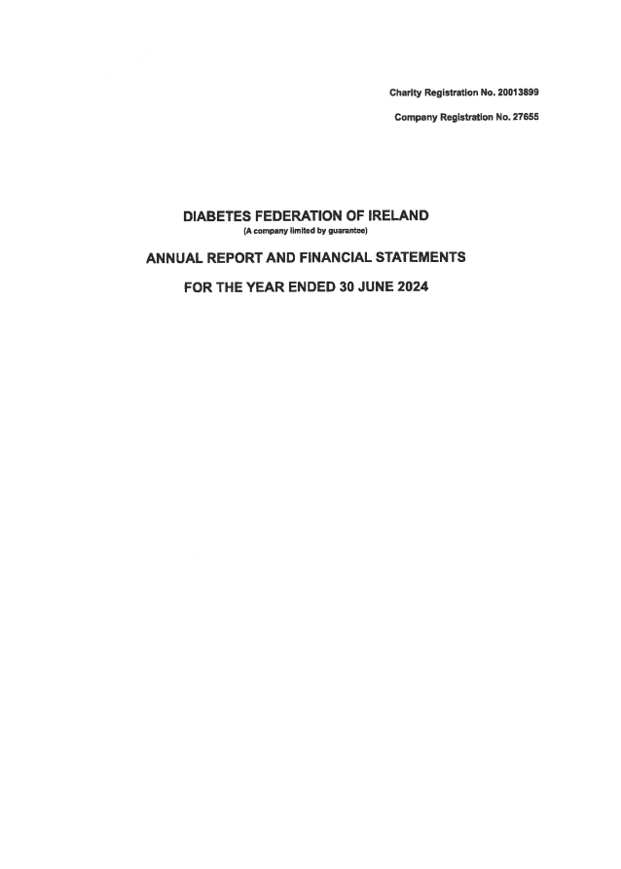

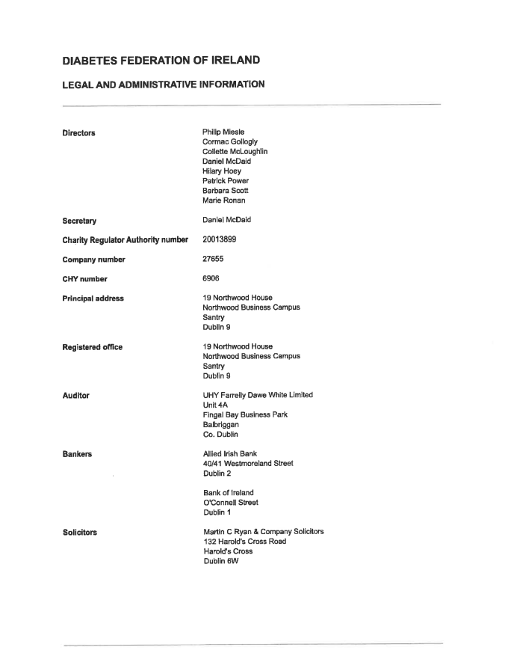

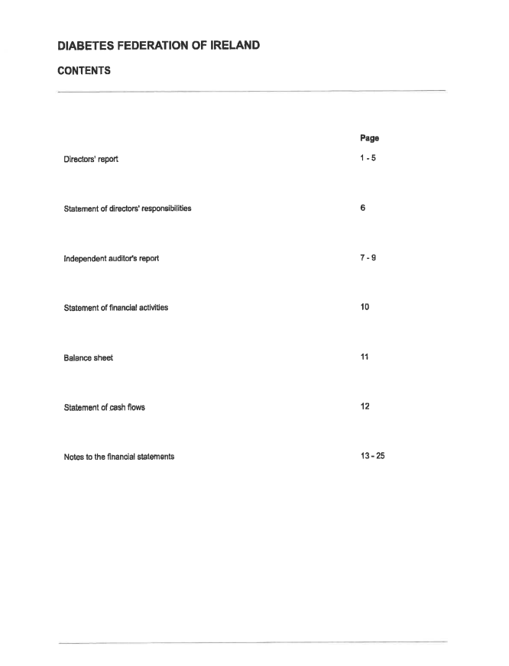

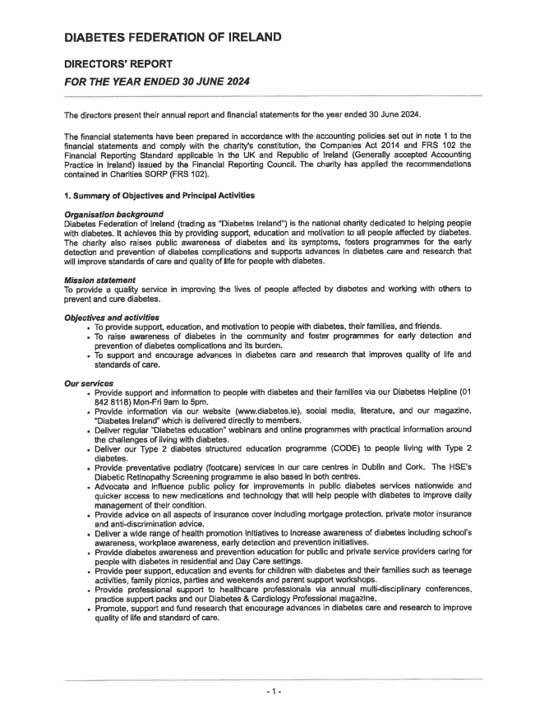

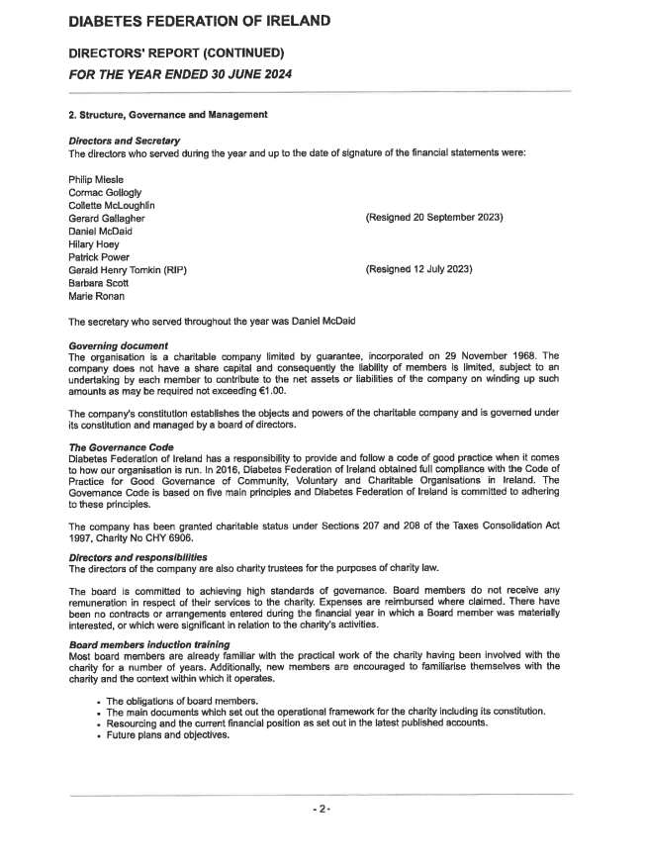

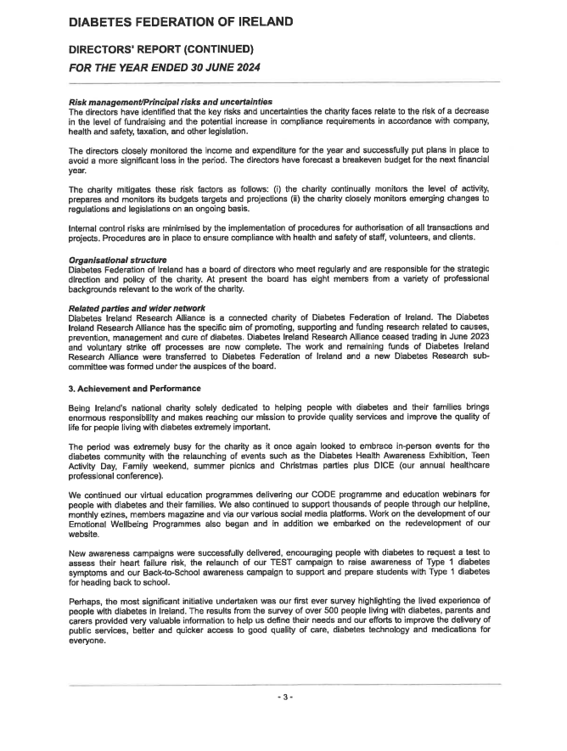

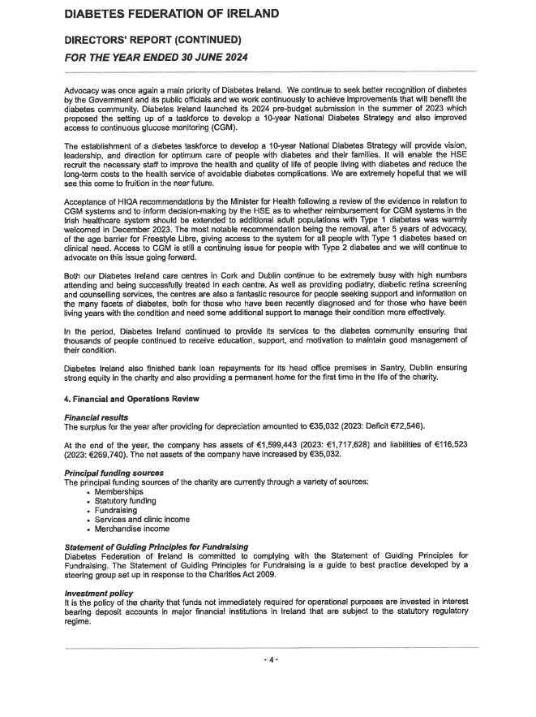

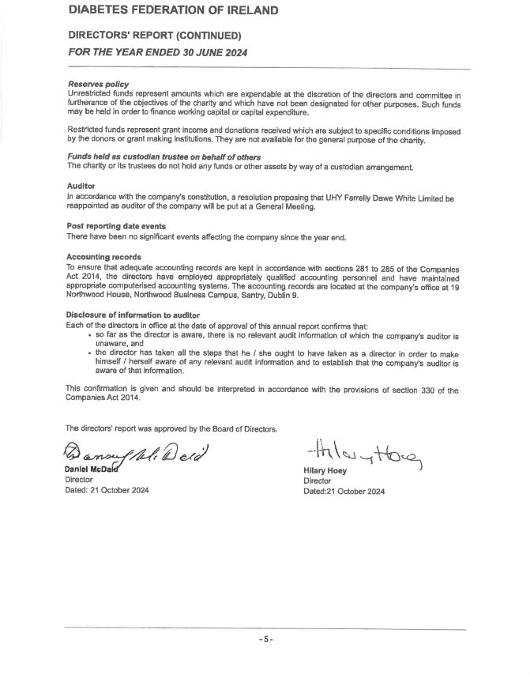

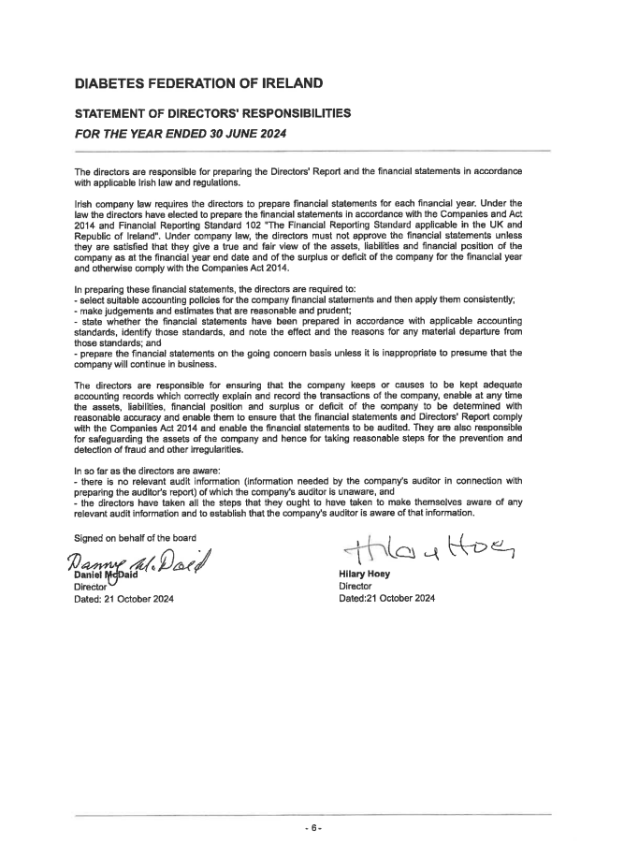

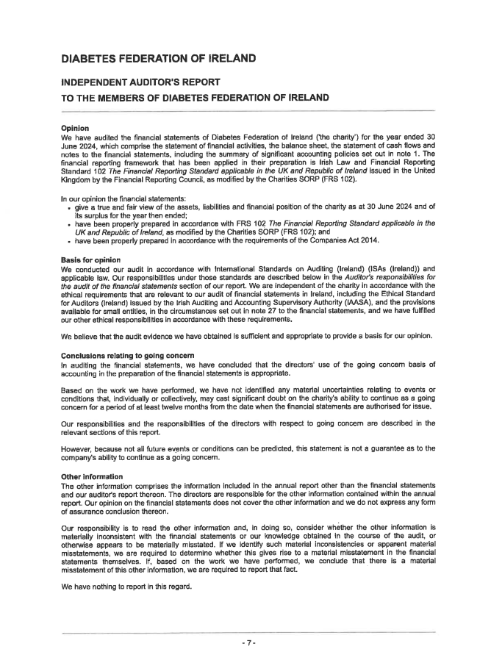

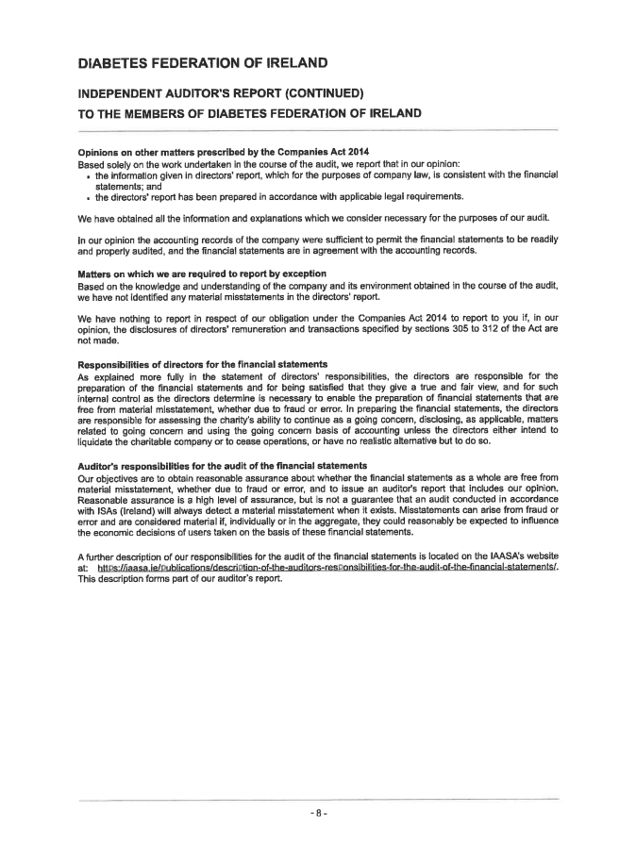

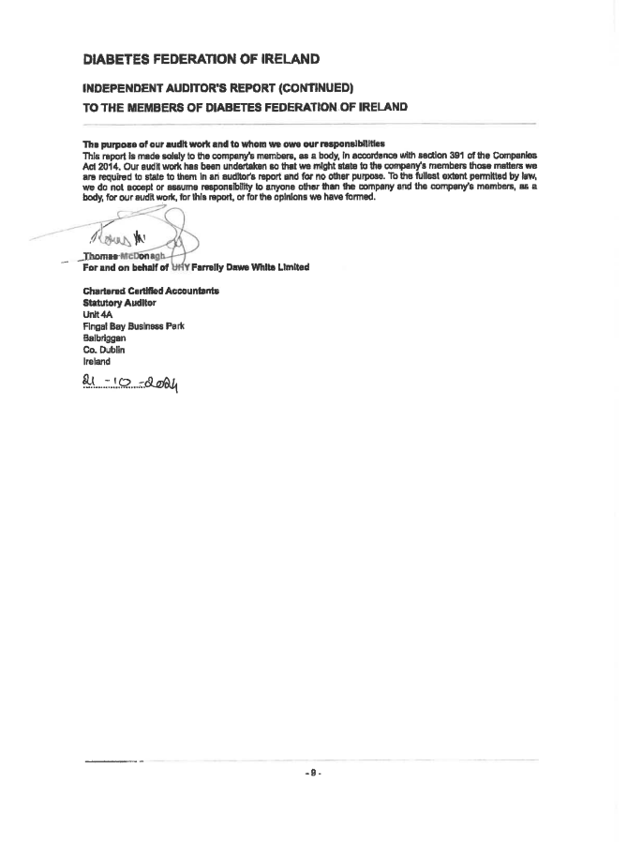

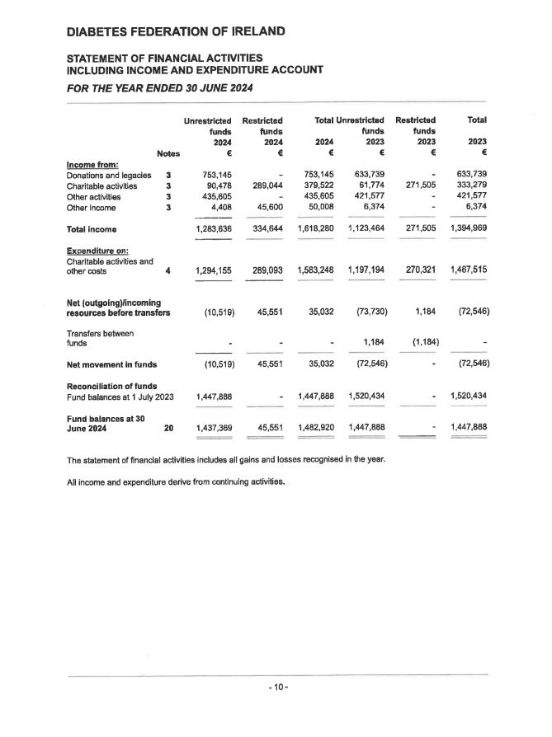

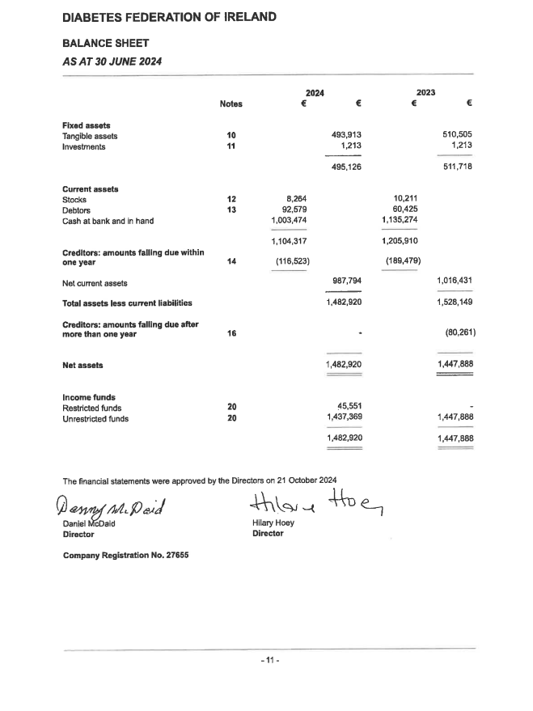

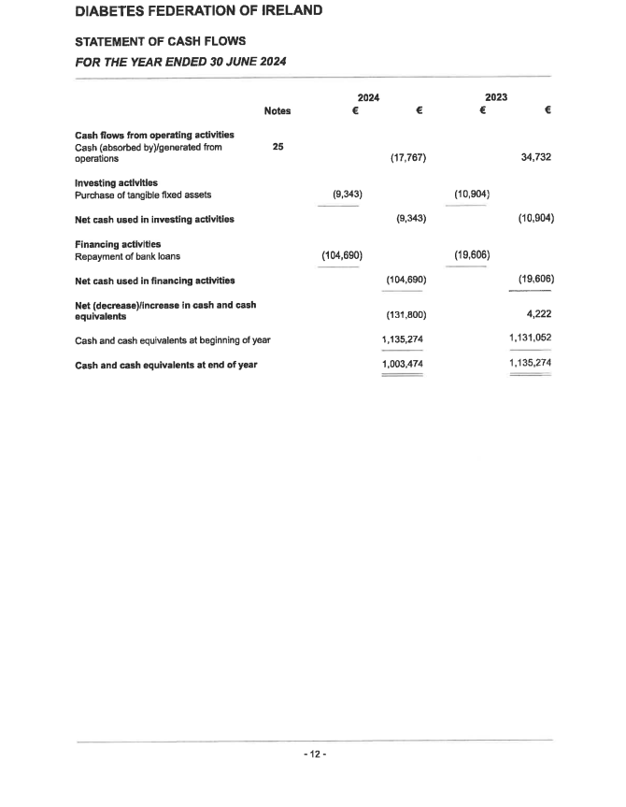

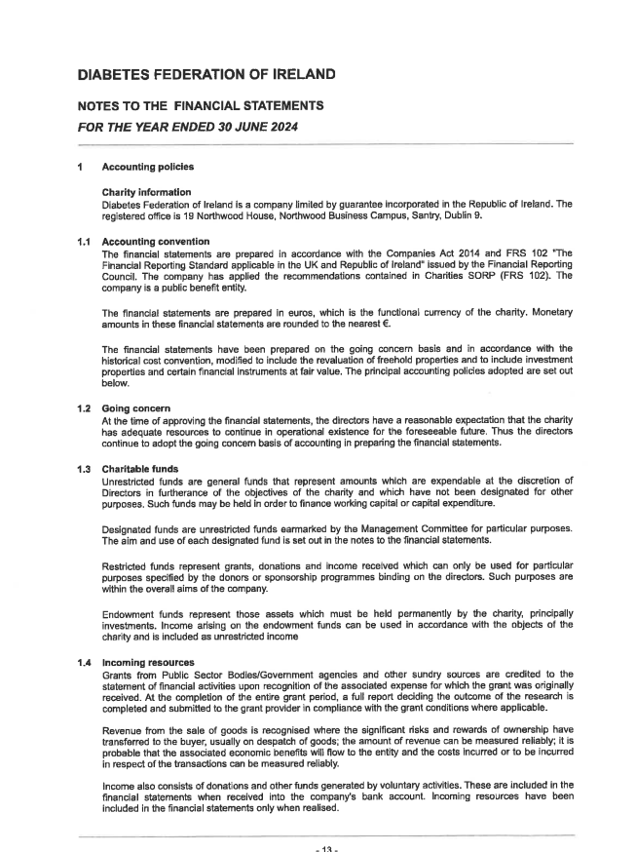

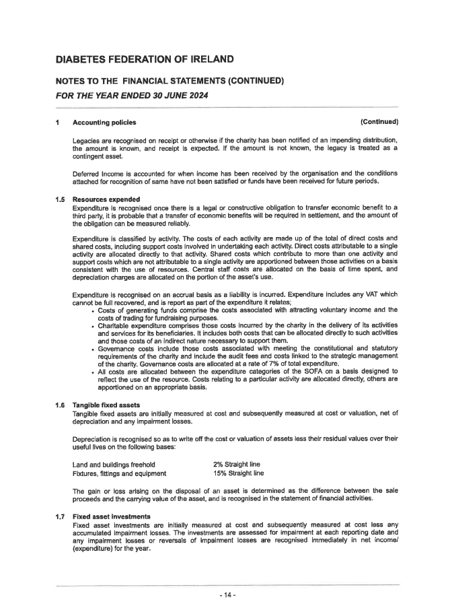

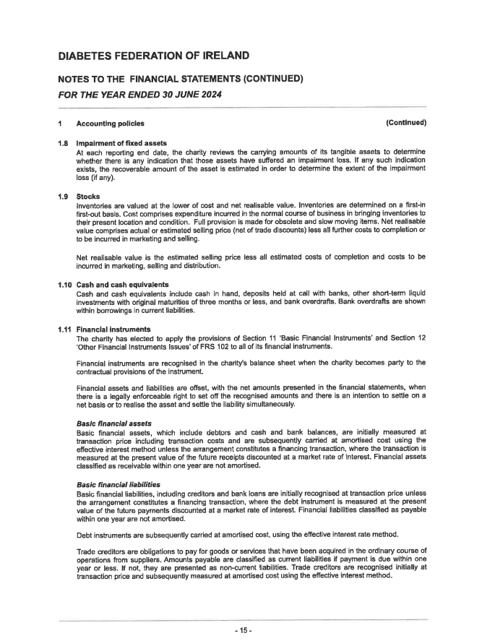

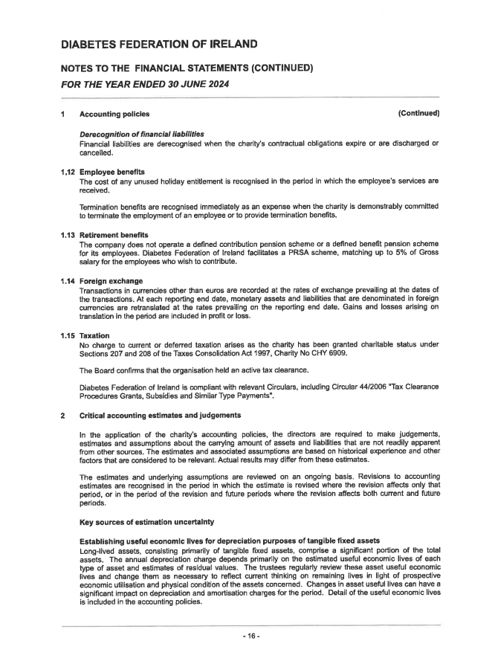

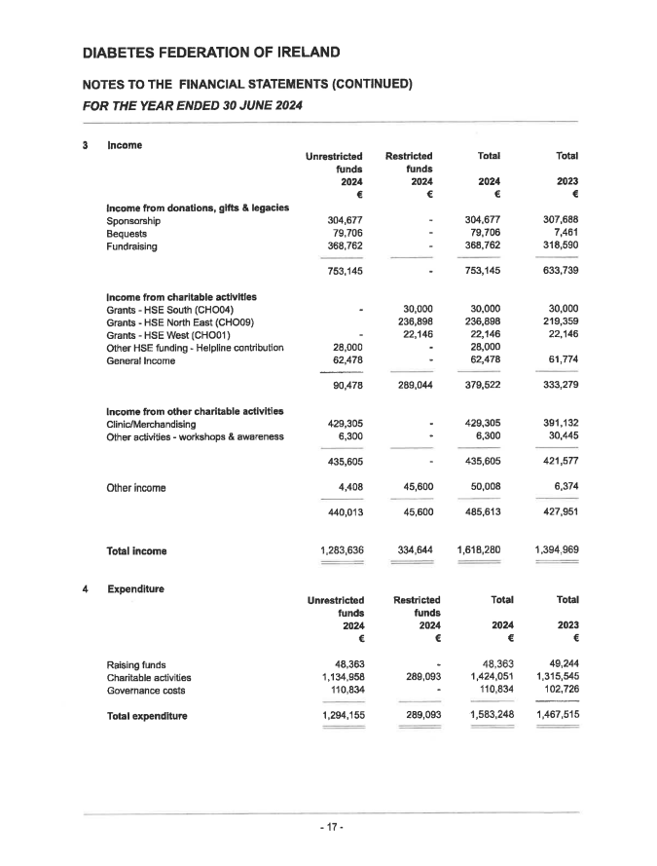

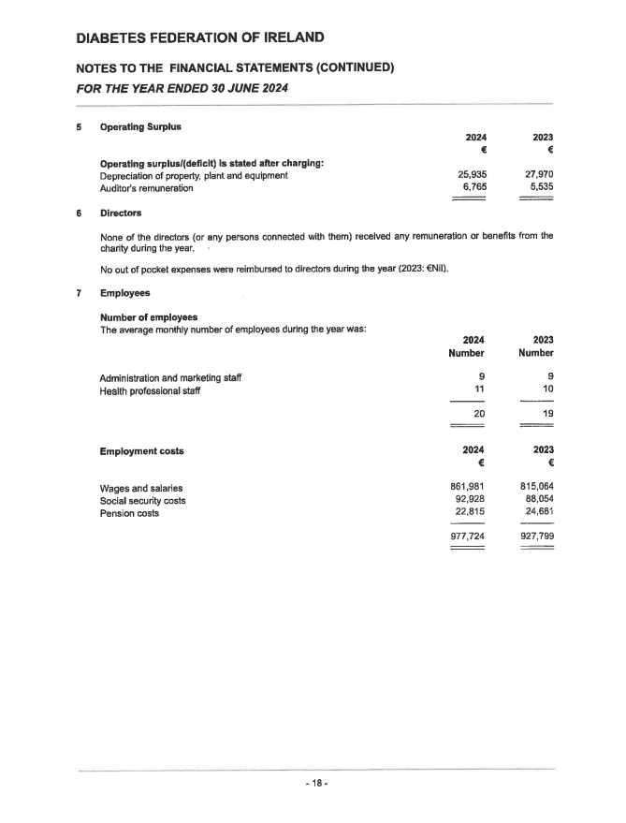

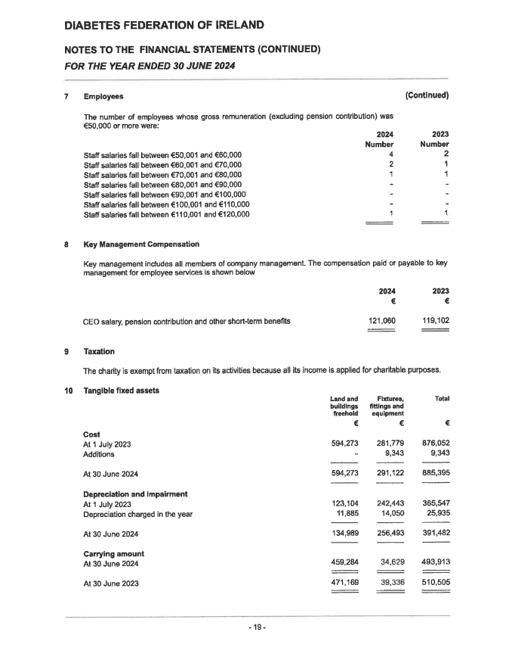

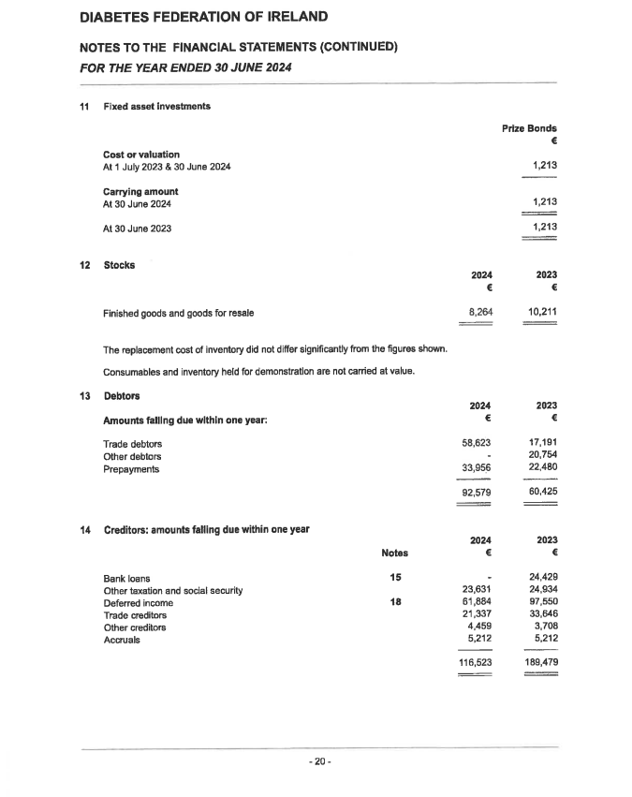

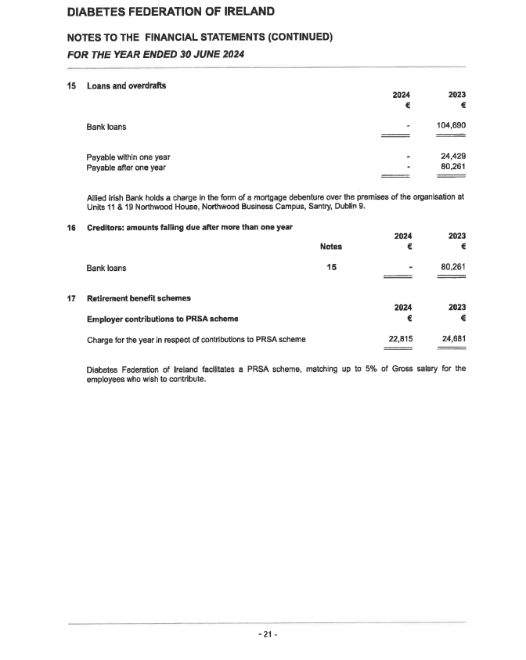

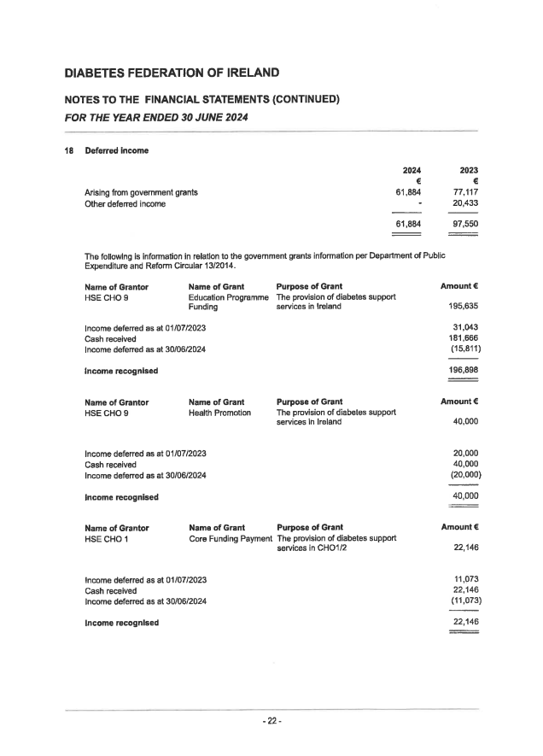

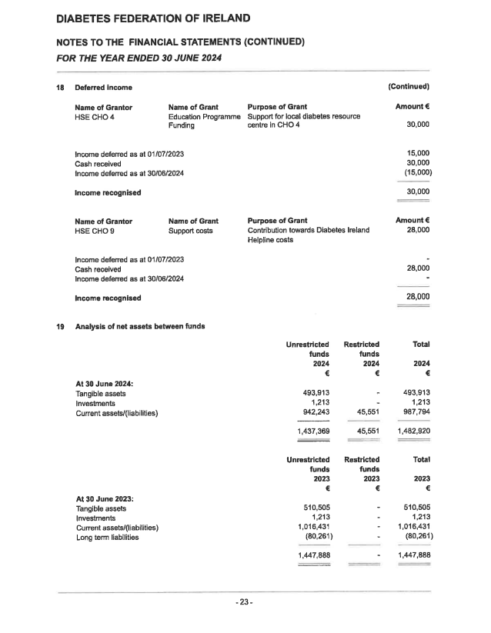

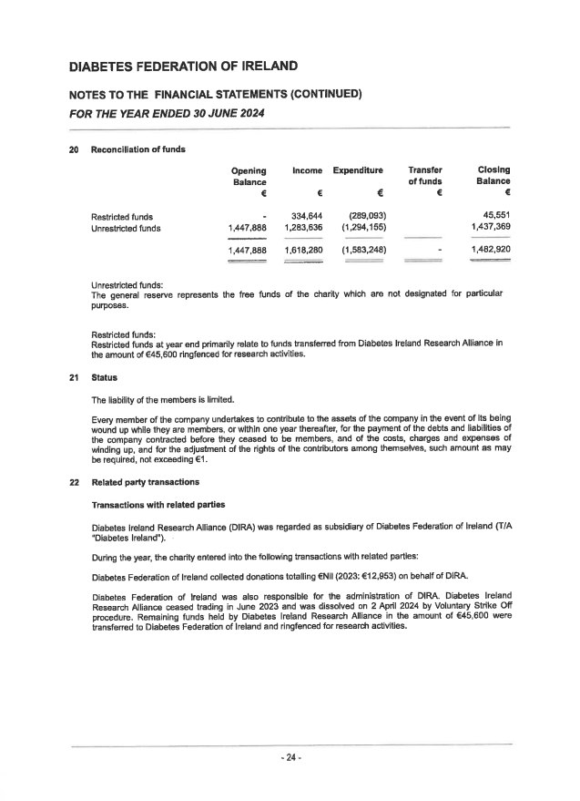

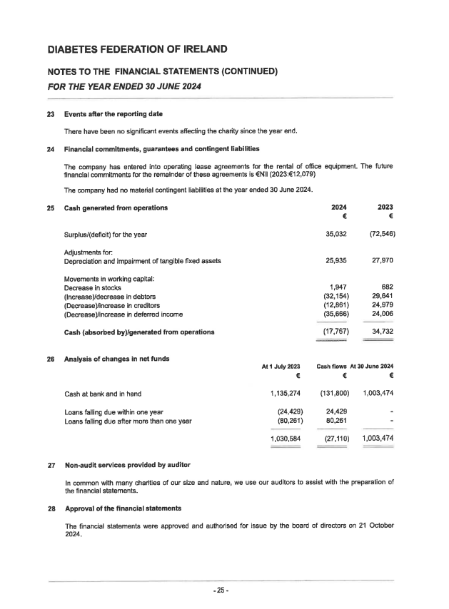

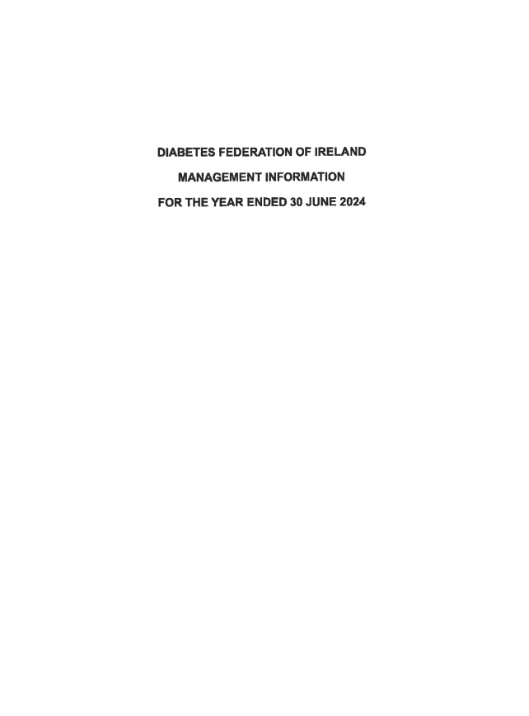

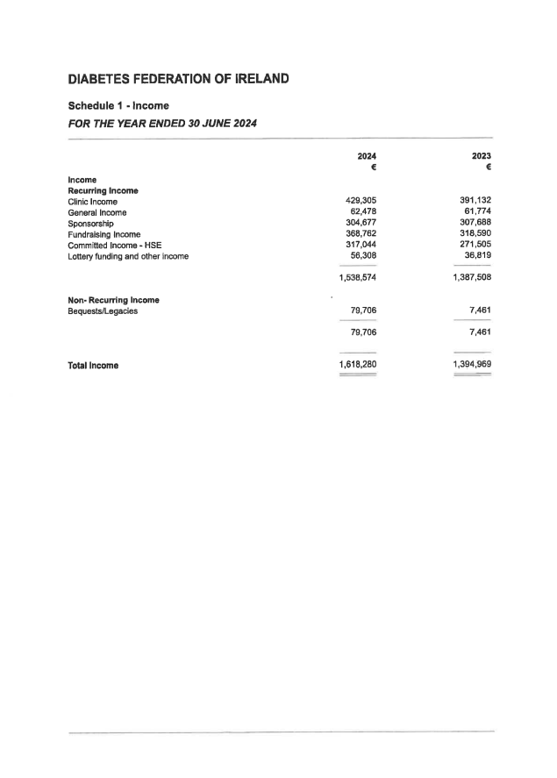

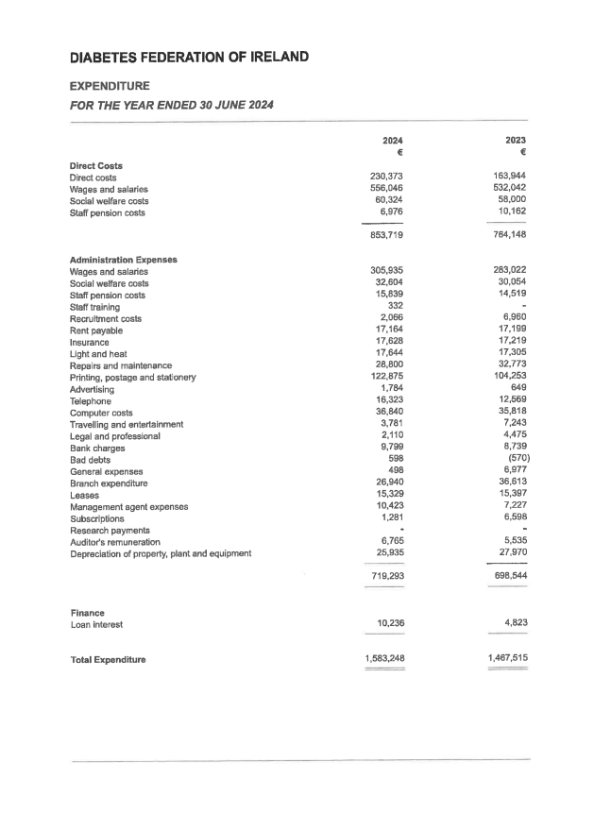
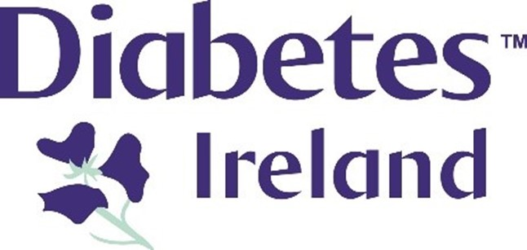

Head Office, Dublin Southern Regional Office, Cork Western Regional Office, Sligo
19 Northwood House, Enterprise House, 1 Wine Street,
Northwood Business Campus, 36 Mary Street, Sligo,
Santry, Cork, F91 RFK1
Dublin 9, DO9 DH30 T12 H6NH Phone: 071 9146001
Phone: 01 842 8118 Phone: 021 4274229 Email: wro@diabetes.ie
Email: info@diabetes.ie Email: corkcarecentre@diabetes.ie

