National Teen Activity Day 2023

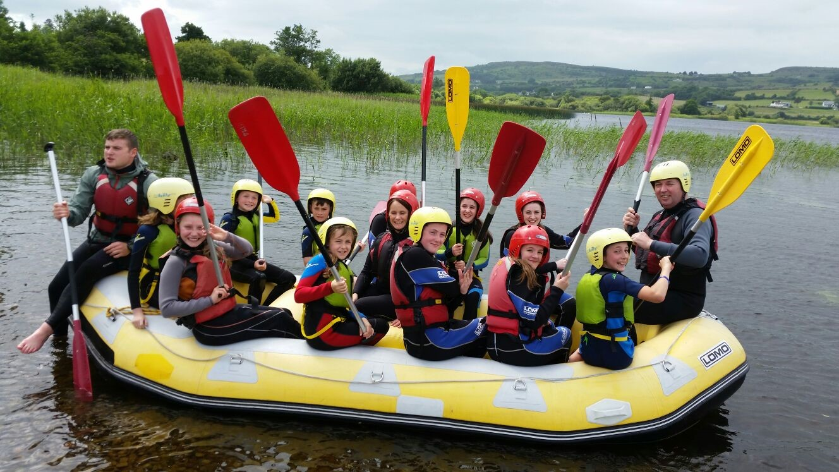

Diabetes Ireland is delighted to invite you to our National Teen Activity Day.
7th of July 2023

Diabetes Ireland, 19 Northwood House, Northwood Business Campus,
Santry, Dublin 9
Call 01 842 8118
Website: www.diabetes.ie Email: info@diabetes.ie

The aim of the day is:

- To encourage teens to engage in adventure activities and learn to maintain good management of their diabetes while doing so.

- To meet other teenagers with diabetes and most importantly to have fun.

- Taking place Friday the 7th of July, 10am – 4pm.

- Open to all children with Diabetes aged 12-15 years.

Details:
- The teen activity day will take place on Friday 14th July 2017, 10am – 4pm (not including travel time)

- The day is open to all children with diabetes aged 10-16 years.

- Events will be held in 4 centres nationwide and you choose which centre you would like to attend.

- We plan to run buses from a number of localities to each of the centres where we have adequate participants.

- A hot lunch and snacks will be provided throughout the day.

- All centres will be fully supervised by trained instructors, volunteer leaders and a healthcare professional.

- The fee per participant is only €20. All other costs will be covered by Diabetes Ireland.

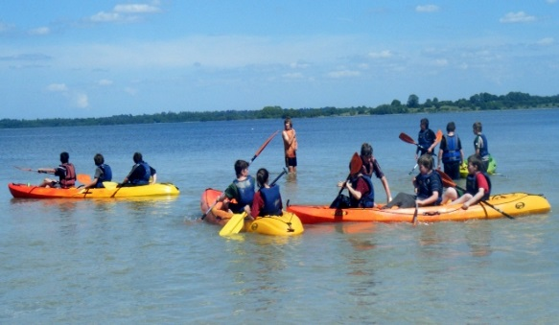
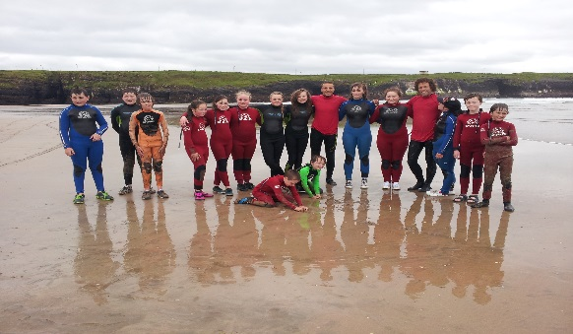
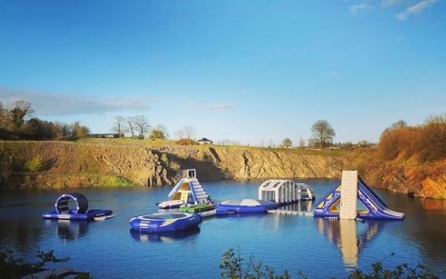
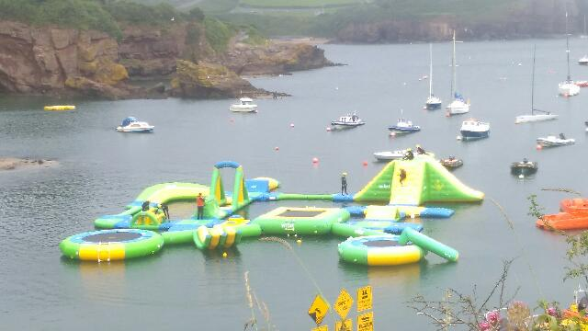

A full list of clothing and other items required will be sent to you nearer the event date.

Please complete the application form overleaf and return it. We will be in touch nearer the event date with finalised details.

Adventure Centres:

Lilliput Adventure Centre, Lough Ennell, Co. Westmeath.

Dunmore East Adventure Centre, Stoney Cove, Dunmore East, Co. Waterford

Ballyhass Lakes, Mallow, Co Cork

Lough Key Forest Park, Boyle, Co Roscommon

Please print information in BLOCK CAPITALS

Teen Activity Day 2023

Participant’s full name:

_____________________________________________

Di Unique No: (Member’s only) DI# _ _ _ _ _ _

Date of birth: _ _ / _ _ / _ _ _ _

Address: _______________________________________________

_______________________________________________

Parent(s) name(s): ________________________________________

Mobile No: ___________________

E-mail: ________________________________________

Centre of choice: ________________________________________

Ability to swim: Yes No

Medical Details:

Date of diagnosis: _______________________

Can participant administer their own insulin? (please circle)

Yes No

What is the current method of insulin administration? (please circle)

Injection Pump

If pump, please state: _________________________________

Insulin regime/ratios give details

____________________________________________

____________________________________________

What method of blood glucose checks are used? (please circle)

Sensor Manual

If sensor, please state: ________________________________

Can participant perform glucose tests by self? (please circle)

Yes No

Is there other medical conditions we need to be aware of? (please circle)

Yes No

If so, please explain.

_____________________________________________

_____________________________________________

Allergies: (please circle)

Yes No

If yes, please state:

_____________________________________________

Specific dietary needs? Coeliac/Lactose intolerance etc. : (please circle)

Yes No

If yes, please state :

____________________________________________

What Hospital/Consultant do you attend:

Name: ________________________________________

Address: ______________________________________

________________________________________________

Telephone: ____________________________________

Email: _________________________________________

Please Note
Please return the application form by post or email.

Caroline Casey
Diabetes Ireland, 19 Northwood House, Northwood Business Campus,
Santry, Dublin 9

Or

Scan to email:
caroline.casey@diabetes.ie
021 4274229

***
Non-Member of Diabetes Ireland €25 fee
Payment methods: (please circle your chosen method)

- Over the phone with a team member.
Caroline will contact you directly.

- Send your card details in the post.
Fill in your card details below.
Card name: _________________________________
Card number: _____________________________________
Exp. Date: _ _/_ _ CVV: __________

