Organisation _____________________ Professional Title: _________________ Name_____________________________

Address: _____________________________________________________________________________________________

Phone: ____________________ Email: _______________________________________

Registration Fee

Members Registration Fee*: €30/£25

Non-Members Registration Fee*: €50/£45

Includes Lunch, Tea & Coffee

*Closing date Thursday 14th November 2019. Please note any applications received after 14th November will incur an additional late fee and total due will then be €70/£55

Method of Payment

(Payment due prior to event)

I enclose Cheque/Postal Order € _______________ or Master VISA

Name on Card: _______________________________________________________

Card Number:

Expiry Date: CCV No:

Card Mailing Address: _____________________________________________________

Are you attending the Thursday pm workshop? Yes No

Are you attending the Thursday pm dinner? Yes No

List any dietary requirements: _____________________________________________________

I agree to full payment being charged to my account: Yes No

Signature: ________________________________ Date: ____________________

Please return this form to:
Diabetes Ireland, 19 Northwood House, Northwood Business Campus, Santry, Dublin 9
Telephone: 01 842 8118 Email: tess.clinch@diabetes.ie

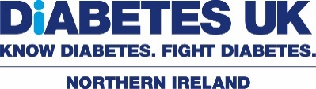
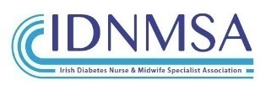
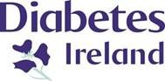

Data Protection
General Terms and Conditions
Please review the latest terms and conditions found at www.diabetes.ie . Diabetes Ireland takes data protection and your privacy seriously. We may pass your personal data to third parties to process your orders and fulfil your requests. We will not provide or sell your personal data to other companies for marketing purposes. We will use data to: • Process your registration and provide applicable conference updates • Send you promotional materials relating to future Diabetes Ireland Professional Conferences and Professional Membership Please note there are exhibitors at this event and that the conference is kindly supported by them. Diabetes Ireland would like to thank our sponsors and all exhibitors for their support of the conference. The sponsors and exhibitors have had no input into the arrangements for the conference, including the agenda, content and speakers. Diabetes Ireland will not take responsibility for any personal information or data you choose to share with exhibitors or delegates directly at the event.
Please tick to confirm you have read and agree to the terms and conditions above

Keeping in touch
If you would like to receive information on future Diabetes Ireland conferences and professional membership, please tick the ways you are happy to be contacted:
By Email
By Phone
By Post
By Text
I do not wish to receive information from Diabetes Ireland

As an attendee with us we would love to keep you updated on news, events, products & services and the different ways you can support us, including financial support. We will not provide or sell your personal data to other companies for marketing purposes. We may pass your personal data to our partners in order to process your orders and fulfil your requests. Please tick the ways you are happy to be contacted:
By Email
By Phone
By Post
By Text
I do not wish to receive information from Diabetes Ireland

