Type 2 Diabetes?

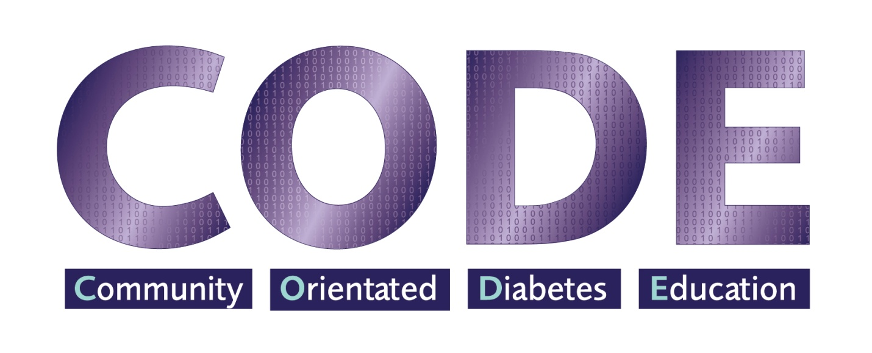

Diabetes Ireland: 19 Northwood House, Northwood Business Campus, Santry, Dublin 9[**www.diabetes.ie**](http://www.diabetes.ie)

[**info@diabetes.ie**](mailto:info@diabetes.ie)

PH. 018428118/ 021 4274229 | CHY6906

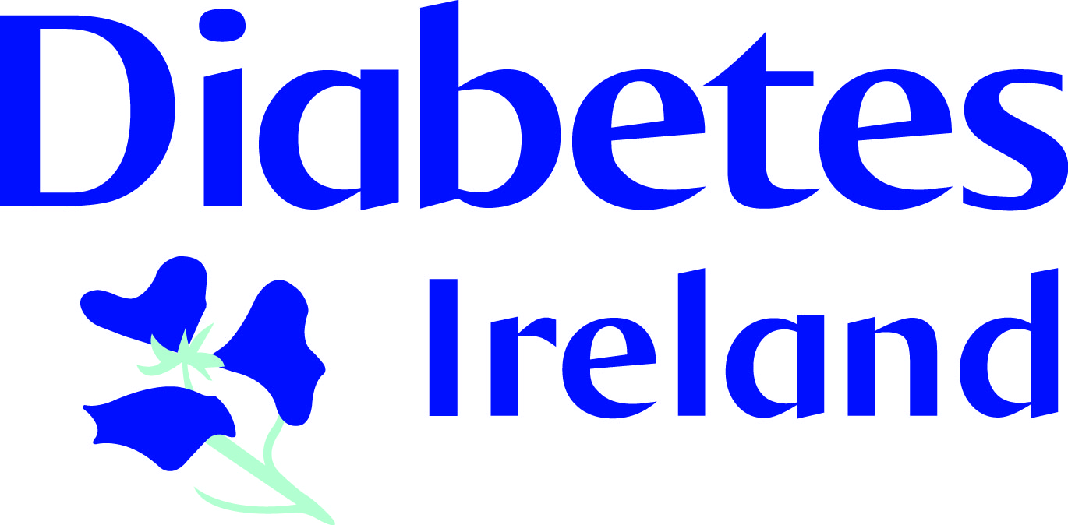

Location: Athy Co Kildare

Monday 4th February 2019

Register ph. 01 8428118, and speak to Sheila

* *4 X 2 hour sessions*
* *First 3 sessions over consecutive weeks*
* *Final review session six months after*

**Topics covered include:**

• Diabetes explained • Risk factors

• Signs and symptoms • Healthy eating

• Physical activity • Complications

• Personal goal setting

• Importance of optimal diabetes control

*CODE is Diabetes Ireland’s free of charge group education programme for people with Type 2 Diabetes or diagnosed prediabetes.*

*CODE aims to deliver general information about diabetes self-management in a local community group setting.*