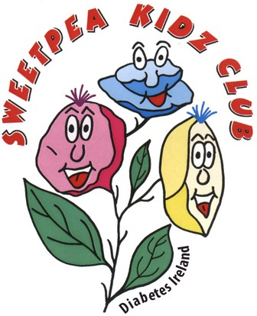Sweetpea Kidz Club Christmas Party

Save the Date...

Sunday 2rd December 2.30- 4.30 pm

The Gresham Hotel O'Connell Street Dublin

DJ & Entertainment

Santa & Elves Presents for the Kids Balloon Artist

Floor Games

Sweetpea Membership Required

Contact Diabetes Ireland

01 842 8118

[Info@diabetes.ie](mailto:Info@diabetes.ie)