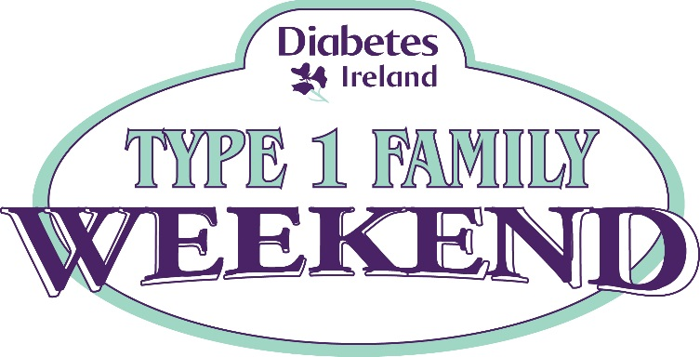

WELCOME TO OUR TYPE 1 DIABETES FAMILY WEEKEND!!!!!

I would like to formally welcome you to Diabetes Ireland’s Type 1 Diabetes Family Weekend in Avon Ri Lakeshore Resort, Blessington Co. Wicklow. Below is a detailed itinerary detailing what to expect across the weekend along with some helpful information on Avon Ri’s facilities to make your stay more enjoyable. If you have any questions please ask myself Vicky Doyle, any of our leaders or at reception. The Diabetes Ireland team hope you have a wonderful and memorable weekend.
Vicky Doyle
Co-ordinator

Weekend Itinerary
Friday
- Check in after 5pm.
- Meet and greet in Russborough Suite 8pm-9pm.
Saturday
Children Activities 10am-5pm (lunch 1-2pm)
- Please see enclosed activities programme for both days and note your child’s age in the designated groups.
Parent workshops 10.30am-12.30
- 10.30am- 11.20am- Helen Fitzgerald Diabetes Nurse Specialist Tallaght Hospital
“New Technologies for diabetes”
- 11.20-11.30am – Tea/Coffee Break
- 11.30- 12.30pm – Kate Gajewska “Parental challenges of Type 1 diabetes: how to deal with your child’s diabetes without losing your mind? Coping skills and tips from a grown up with diabetes”.
Sunday
Check out is at 11am. Families must check out of their accommodation prior to children’s activities and workshops.
Children’s Activities- 10am-1pm
- Please see Sunday’s activity programme.
Parent Workshop – 10.30am-12.30
- 10.30am-11.30am – Prof Hilary Hoey Paediatric Consultant Endocrinologist “Family Unit Health
- 11.45am-12.30pm – Question and Answer session with Prof Hilary Hoey and Dr. Anna Clarke.
Farewells at 1pm

Facilities
- The restaurant has limited places so please book with Avon Ri reception on 045-900670 prior to the event if you are intending on eating out on Saturday evening. There is an extensive bar menu/breakfast menu and children’s menu. Please see www.avonri.com to view these food menus. There are numerous restaurants in Blessington town also.
- The houses are fully equipped for self-catering.
- There is plenty of parking within the vicinity with approximately two car park spaces for each house.
- The swimming pool, gym, sauna and Jacuzzi are open from 9am-6pm on Saturday and Sunday.
- Air beds/Travel cots for houses are available upon request.
- Shower gel and towels are provided in the houses. If extra are needed dial -0- for reception.
- DVD players can be given from reception upon request.
Have a great weekend!!!

